Elastic maps

Contents

1 Introduction 3

2 Map geometry 3

3 Projection data points onto map 5

3.1 Projection of data points to node 5

3.2 Projection of data onto nearest edge 6

3.3 Projection of data onto nearest face 7

4 Fraction of variance unexplained 9

5 Map extrapolation 10

5.1 Extension for OneDMap 10

5.2 Extension for rect2DMap 11

5.3 Extension for tri2DMap 13

6 EM (Elastic map) 14

6.1 Elastic energy 15

6.2 Weighted version 17

6.3 $λ$ and $μ$ choice 17

6.4 PQSQR for data 19

6.5 Weighted PQSQ version 20

6.6 Function description 20

7 Data with gaps 20

7.1 Representation of incomplete points 20

7.2 Distance calculation 21

7.3 Learning of map for incomplete data 21

7.4 Projection of incomplete points into nodes 22

7.5 Projection of incomplete points on edges 22

7.6 kNN data repair 22

7.7 SVD with gaps 23

8 SOM 25

9 Tests 25

9.1 Two arcs 25

9.2 Two arcs with x and y shift 27

9.3 Fragment of sphere 29

9.4 Two fragments of sphere 30

10 Appendix A. Formulas derivation 31

11 Appendix B. Examples of map descriptions 32

11.1 OneDMap 32

11.2 rect2DMap 33

11.3 tri2DMap 34

12 References 36

# Introduction

Presented package ElMap is developed to form nonlinear manifolds by two techniques: Self-Organizing Map (SOM) and Elastic Map (EM). Main purpose is EM implementation and SOM is added as auxiliary feature.

This document contains theoretical description, user guide and technical description.

# Map geometry

Package developed for 1D and 2D maps. It is possible to use maps with more than two dimensions but this functionality is not basic. This class is basic class of package because EM and SOM are the techniques to fit map for data only.

There is only one type of 1D maps: piecewise linear (Figure 1a). It is possible to construct many different 2D maps. ElMap includes two standard 2D maps: rectangular (Figure 1b) and triangular (Figure 1c). Package also contains possibility to add user implemented map with arbitrary structure.

a

b

c

Figure 1. Standard map geometry: a) 1D map, b) rectangular 2D map and c) triangular 2D map. Red segments corresponds to example of ribs.

There are three standard descendants of ***MapGeometry*** class:

1. OneDMap is one dimensional map (Figure 1a);
2. rect2DMap is two dimensional map with rectangular grid (Figure 1b);
3. tri2DMap is two dimensional map with triangular grid (Figure 1c).

Each map must be descendant of ***MapGeometry*** class and must include following property:

***Dimension*** is number of internal coordinates.

***Internal coordinates*** is the set of coordinates for each node in the map defined coordinates. For example, for 1D map there is only one coordinate for each node: leftmost node has coordinate one, the next node has coordinate two and so on. For rectangular 2D map left bottom node has coordinates $(1,1)$, the next node in the bottom line has coordinates $(2,1)$, the node in the leftmost column and in the first line above bottom one has coordinates $(1,2)$, the node in the intersection of $i$ th row from the bottom and $j$ th column from the left has coordinates $(i,j)$. For triangular 2D map the nodes in the bottom row have coordinates $\left(1,0\right),\left(2,0\right),…$; nodes in the line above the top have coordinates $\left(\frac{3}{2},\frac{\sqrt{3}}{2}\right),\left(\frac{5}{2},\frac{\sqrt{3}}{2}\right),…$; nodes in the next rows have coordinates $\left(1,\frac{2\sqrt{3}}{2}\right),\left(2,\frac{2\sqrt{3}}{2}\right),…$.

***Mapped coordinates*** is the set of coordinates of nodes in the data space. These coordinates are initially defined by initializing procedure and then adjusted by the map fitting. Procedure of map fitting is external with respect to the map and can be provided by SOM or EM fitting process.

***Links*** is the set of map edges and completely defined by the map geometry. Each edge is the fragment of straight line which connect the nearest nodes in the Figure 1: 4 edges in the subfigure a, 112 edges in the subfigure b and 111 edges in the subfigure c.

***Ribs*** is set of three adjacent nodes which are belonged to one straight line in the internal coordinates. For one dimension map rib is set of two adjacent edges. For rectangular two dimension map it is pair of horizontal adjacent edges or vertical adjacent edges. For triangular two dimension map there are three directions of ribs. Examples of ribs are presented in Figure 1 by red segments.

***Disp*** is dispersion measure for PQSQ approach. To calculate disp we have to calculate distance from each data point to the nearest initial node and then take maximum of these distances.

***Preproc*** is true if data were preprocessed.

***Means*** is empty if ***preproc*** is false and mean of data otherwise.

***PCs*** is empty if ***preproc*** is false and set of PCs otherwise.

Each map must provide following methods.

***Constructor*** is method to create map. Constructor creates arrays of nodes, edges and ribs and defines internal coordinates of nodes. Name of constructor is map dependent. Constructor’s input arguments are map dependent too.

***Init*** is the method of map initialization. This method perform required data preprocessing (see methods “preprocessDataInit” and “preprocessDataInit”). This method defines an initial mapped coordinates. In accordance of results of paper [1] three methods have to be implemented by each map: random initialization, random selection and principal component initialization. Input arguments of this method are set of data points and type of initialization. Default version of this method is implemented in the ***MapGeometry*** class.

***Project*** is the method to calculate projection of data point (points) into map. There are $d+1$ types of projection for $d$ dimensional map: 0 means projection into nearest node of map, 1 means projection onto nearest edge of map, 2 means projection onto nearest face of map. Projection can be calculated in the internal or mapped coordinates. There are three input arguments for this method: set of point to project, type of projection (integer number) and coordinates space for projection: ‘internal’ or ‘mapped’. ***MapGeometry*** class implements this method for the types 0, 1 and 2.

***distance*** is method to calculate distances between two nodes in the internal coordinates. This method is useful for SOM fitting procedure. Is not implemented yet.

***getFaces*** is optional method. It must be implemented by ***MapGeometry*** descendant for projection onto faces. Each face is the set of three nodes. This method cannot be implemented for one dimensional map.

***extendPrim*** is primitive method to extrapolate map to reduce border effect. This method is used by ***extend*** method of ***MapGeometry*** class.

***getBorder*** is method to form list of border nodes.

Following methods is provided by the ***MapGeometry*** class:

***getDimension*** is method to get map dimension.

***getInternalCoordinates*** is method to access the internal coordinates of map.

***getMappedCoordinates*** is method to access the mapped coordinates of map.

***getLinks*** is method to access edges of map.

***getRibs*** is method to access ribs of map.

***preprocessDataInit*** is the method to preprocess data. User can specify number of the first principal components to use. Otherwise, if number of data points is less than dimension of data space, then the first number of points minus one principal components are used to preprocess data. Principal components are calculated ones in this method.

***preprocessData*** is preprocess data if ***preprocessDataInit*** method created nonempty preprocessing.

***getDisp*** is method to access disp field of map.

***associate*** is method to find nearest node for each data point. This method returns the number of nearest node and squared distance to it.

***borderCases*** is method to calculate fraction of data points which are projected into border nodes (see “Map extrapolation”).

***extend*** is method to extrapolate maps without training. This method used ***extendPrim*** method of descendant.

***FVU*** is method to calculate Fraction of variance unexplained.

***putMapped*** is method to put fitted mapped coordinates to the map.

# Projection data points onto map

For each map we can consider several types of projections: projection into nearest node, projection onto nearest edge or face. In this section all formulas which are necessary for projection calculation are derived.

## Projection of data points to node

It is the simplest type of projection. Method calculates distances from each data points to each map node and selects the node with least distance for each data point. Examples of visualization of this type of projection are presented in Figure 2. Number of points which are projected to the same node is presented as size of circle.

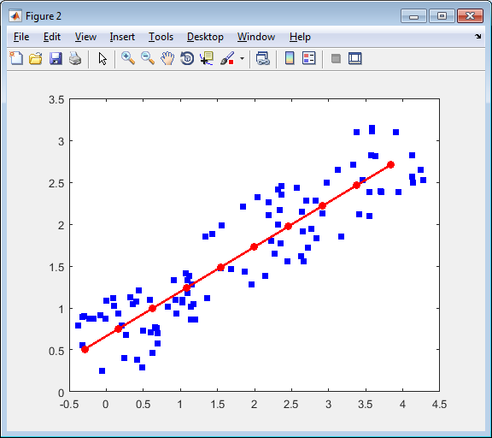 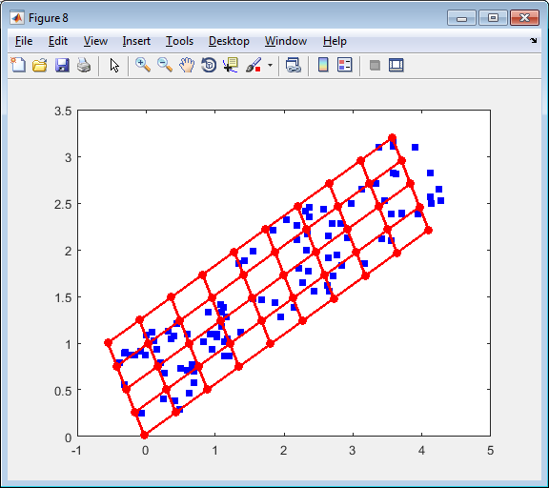 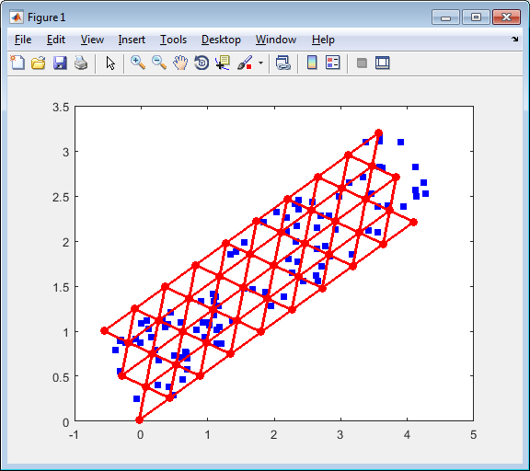

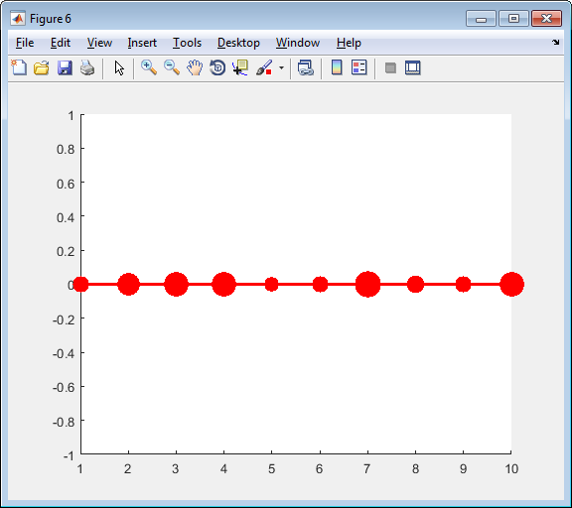 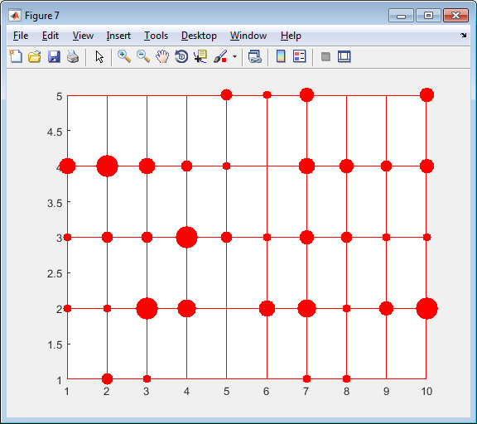 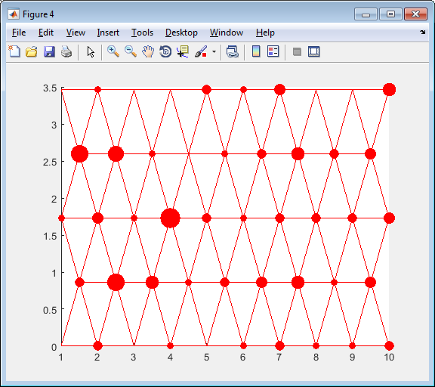

Figure 2. Examples of data points projection to the nearest node: top row contains graphs in the original space and bottom row contains corresponding graphs in the internal coordinates; left column presents the one dimensional map, central column presents rectangular 2D map and right column presents the triangular 2D map.

## Projection of data onto nearest edge

It is important to stress that globally nearest edge sometimes does not contain nearest node (see Figure 3). It is rare case. We consider the projection of point to globally nearest edge. Let us consider data point $d$ and edge defined by two nodes $x_{0},x_{1}$. Mapped coordinates of these nodes we denote $y_{0},y_{1}$. See Figure 4 for calculation illustration.

Figure 3

Projection to line which contain the edge $\left(y_{0},y_{1}\right)$ can be written as convex combination of the nodes which define this edge:

|  |  |
| --- | --- |
| $$d^{'}=ay_{0}+\left(1-a\right)y_{1}.$$ | (1) |

Interior of the edge is defined by inequality $0≤a≤1$. Let us find projection of arbitrary point $d$:

$$y_{1}$$

$$y_{0}$$

$$d$$

$$d^{'}$$

Figure 4

$$y_{1}$$

$$y_{0}$$

$$d$$

$$d^{'}$$

$$d$$

$$y_{1}$$

$$d^{'}$$

$$y_{0}$$

a)

b)

c)

$$dist^{2}\left(d,d^{'}\right)=\sum_{i=1}^{n}{{\left(d_{i}-ay_{0i}-\left(1-a\right)y_{1i}\right)}^{2}}.$$

In the projection point this distance is minimal. To find parameter $a$ we have to differentiate squared distance with respect to $a$ and equal derivative to zero:

$$\frac{∂dist^{2}\left(d,d^{'}\right)}{∂a}=\frac{∂}{∂a}\sum_{i=1}^{n}{{\left(d_{i}-ay_{0i}-\left(1-a\right)y_{1i}\right)}^{2}}=-2\sum_{i=1}^{n}{\left(d_{i}-ay_{0i}-\left(1-a\right)y_{1i}\right)\left(y_{1i}-y_{0i}\right)}=0⇒$$

$$\sum_{i=1}^{n}{\left(d_{i}-y_{1i}\right)\left(y_{1i}-y_{0i}\right)}=a\sum_{i=1}^{n}{\left(y_{0i}-y_{1i}\right)\left(y_{1i}-y_{0i}\right)}⇒$$

|  |  |
| --- | --- |
| $$a=\frac{\left(d-y_{1},y_{0}-y_{1}\right)}{\left(y_{0}-y_{1},y_{0}-y_{1}\right)},$$ | (2) |

where $(∙,∙)$ is the scalar or dot product of two vectors.

We are interested in the internal points only. Case where $a<0$ corresponds to Figure 4b and case where $a>1$ corresponds to Figure 4c. It means that we have to adjust calculated parameter:

|  |  |
| --- | --- |
| $$a_{n}=max⁡(0,\min{(1,a)).}$$ | (3) |

To calculate distance we can use formula

|  |  |
| --- | --- |
| $$dist^{2}\left(d,d^{'}\right)=\left(d-y_{1},d-y_{1}\right)+\left(a_{n}^{2}-2aa_{n}\right)\left(y_{0}-y_{1},y_{0}-y_{1}\right).$$ | (4) |

The general algorithm is:

1. Calculate parameters of projections by formula (2).
2. Calculate adjusted parameter by formula (3)
3. Calculate distances by formula (4). Select the nearest edge and calculate coordinates of projection onto nearest edge by formula (1).

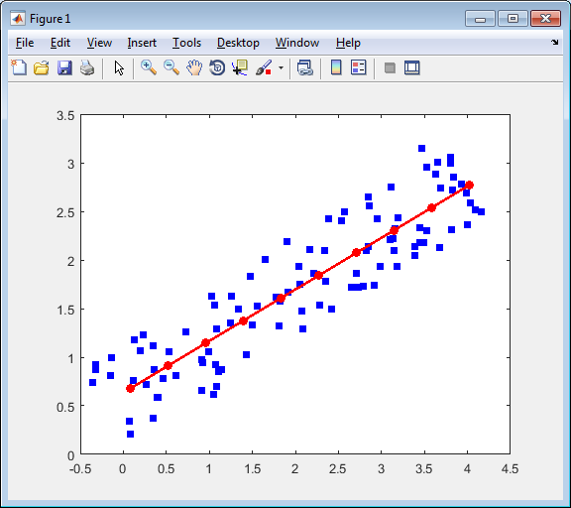 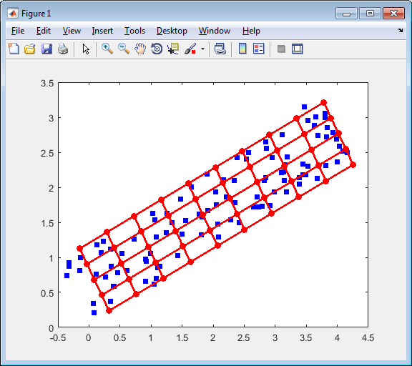 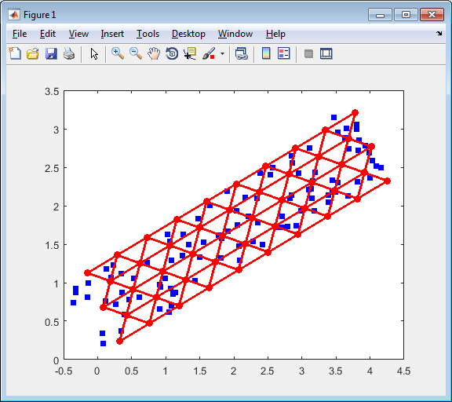

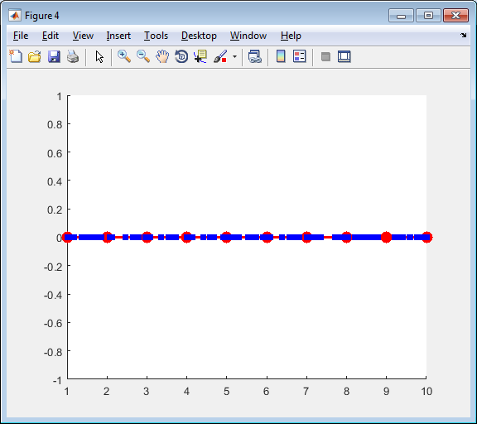 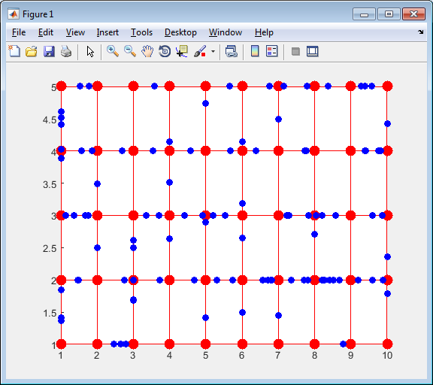 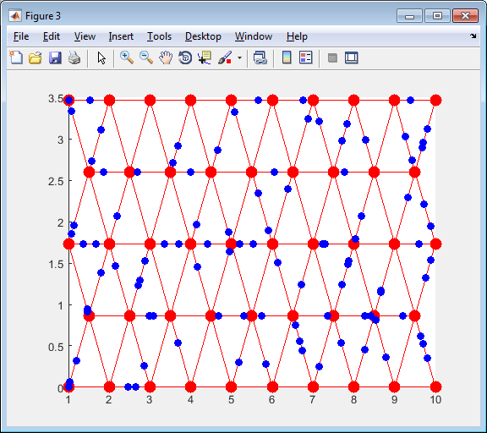

Figure 5. Examples of data point projection to the nearest node: top row contains graphs in the original space and bottom row contains corresponding graphs in the internal coordinates; left column presents the one dimensional map, central column presents rectangular 2D map and right column presents the triangular 2D map.

## Projection of data onto nearest face

Projection onto nearest face is not defined for all map geometries. To use this option used map geometry must implement method getFaces. Two of three standard map geometries are implemented it. For tri2DMap each triangle is a face. For rect2DMap faces are presented in the Figure 6.

Figure 6

Let us implement barycentric coordinates (see Figure 7). We need to find the point $d^{'}$ in the triangle $y_{0},y_{1},y_{2}$ which is nearest to the point $d$. Barycentric coordinates of point $d'$ are $\left(a_{0},a_{1},a_{2}\right)$:

$$d'$$

$$y_{2}$$

$$a_{0}$$

$$a_{1}$$

$$a_{2}$$

$$y_{0}$$

$$y_{1}$$

Figure

For barycentric coordinates there is restriction

$$a_{0}+a_{1}+a_{2}=1.$$

Squared distance between points $d$ and $d'$ is:

$$dist^{2}\left(d,d^{'}\right)=\sum_{i=1}^{n}{{\left(d_{i}-a_{0}y_{0i}-a_{1}y_{1i}-\left(1-a_{0}-a_{1}\right)y_{2i}\right)}^{2}}.$$

To find the required values of $\left(a_{0},a_{1},a_{2}\right)$ we need to find the minimum of squared distance. To do it differentiate squared distance with respect to $a_{0}$ and $a_{1}$:

$$\frac{∂dist^{2}\left(d,d^{'}\right)}{∂a_{0}}=\frac{∂}{∂a_{0}}\sum_{i=1}^{n}{{\left(d_{i}-a_{0}y_{0i}-a_{1}y_{1i}-\left(1-a_{0}-a_{1}\right)y_{2i}\right)}^{2}}=2\sum_{i=1}^{n}{\left(d_{i}-a_{0}y_{0i}-a_{1}y_{1i}-\left(1-a_{0}-a_{1}\right)y_{2i}\right)\left(y_{2i}-y_{0i}\right)}=0$$

$$\frac{∂dist^{2}\left(d,d^{'}\right)}{∂a_{1}}=\frac{∂}{∂a_{1}}\sum_{i=1}^{n}{{\left(d_{i}-a_{0}y_{0i}-a_{1}y_{1i}-\left(1-a_{0}-a_{1}\right)y_{2i}\right)}^{2}}=2\sum_{i=1}^{n}{\left(d_{i}-a_{0}y_{0i}-a_{1}y_{1i}-\left(1-a_{0}-a_{1}\right)y_{2i}\right)\left(y_{2i}-y_{1i}\right)}=0$$

We can rewrite these equations as

$$a_{0}\sum_{i=1}^{n}{{\left(y_{2i}-y_{0i}\right)}^{2}}+a_{1}\sum_{i=1}^{n}{\left(y_{2i}-y_{1i}\right)\left(y_{2i}-y_{0i}\right)}=\sum_{i=1}^{n}{\left(y_{2i}-d_{i}\right)\left(y_{2i}-y_{0i}\right)}$$

$$a_{0}\sum_{i=1}^{n}{\left(y_{2i}-y_{1i}\right)\left(y_{2i}-y_{0i}\right)}+a_{1}\sum_{i=1}^{n}{{\left(y_{2i}-y_{1i}\right)}^{2}}=\sum_{i=1}^{n}{\left(y_{2i}-d_{i}\right)\left(y_{2i}-y_{1i}\right)}$$

By using the dot product we can rewrite the last equations as

$$a_{0}\left(y_{2}-y_{0},y_{2}-y_{0}\right)+a_{1}\left(y_{2}-y_{1},y_{2}-y_{0}\right)=\left(y_{2}-d,y_{2}-y_{0}\right)$$

$$a_{0}\left(y_{2}-y_{1},y_{2}-y_{0}\right)+a_{1}\left(y_{2}-y_{1},y_{2}-y_{1}\right)=\left(y_{2}-d,y_{2}-y_{1}\right)$$

We apply Cramer formula to solve this system of linear equations:

$$a_{0}=\frac{\left(y_{2}-d,y_{2}-y_{0}\right)\left(y_{2}-y_{1},y_{2}-y_{1}\right)-\left(y_{2}-d,y_{2}-y_{1}\right)\left(y_{2}-y_{1},y_{2}-y_{0}\right)}{\left(y_{2}-y_{0},y_{2}-y_{0}\right)\left(y_{2}-y_{1},y_{2}-y_{1}\right)-{\left(y_{2}-y_{1},y_{2}-y_{0}\right)}^{2}},$$

$$a_{1}=\frac{\left(y_{2}-d,y_{2}-y_{1}\right)\left(y_{2}-y_{0},y_{2}-y_{0}\right)-\left(y_{2}-d,y_{2}-y_{0}\right)\left(y_{2}-y_{1},y_{2}-y_{0}\right)}{\left(y_{2}-y_{0},y_{2}-y_{0}\right)\left(y_{2}-y_{1},y_{2}-y_{1}\right)-{\left(y_{2}-y_{1},y_{2}-y_{0}\right)}^{2}}.$$

Barycentric coordinates system allows us to recognise cases when projection point is located out of face but cannot help us to improve this situation. It means that we have to calculate projection onto face plane and onto each edge by usage the formula (2) for each edge. Let us denote

$$y_{20}=y_{2}-y_{0},y_{21}=y_{2}-y_{1}, y_{10}=y_{1}-y_{0}.$$

In this case we can write the coefficients for projections for each edge as

|  |  |
| --- | --- |
| $$a_{20}=\frac{\left(y_{2},y_{20}\right)-\left(d,y_{20}\right)}{\left(y_{20},y_{20}\right)},$$ | (5) |
| $$a_{21}=\frac{\left(y_{2},y_{21}\right)-\left(d,y_{21}\right)}{\left(y_{21},y_{21}\right)},$$ | (6) |
| $$a_{10}=\frac{a_{20}\left(y_{20},y_{20}\right)-a_{21}\left(y_{21},y_{21}\right)-(y_{21},y_{10})}{\left(y_{10},y_{10}\right)}.$$ | (7) |

Coefficients of projection onto face can be rewritten as

|  |  |
| --- | --- |
| $$a_{0}=\frac{a_{20}\left(y_{20},y_{20}\right)\left(y_{21},y_{21}\right)-a_{21}\left(y_{21},y_{21}\right)\left(y_{21},y_{20}\right)}{\left(y_{20},y_{20}\right)\left(y_{21},y_{21}\right)-{\left(y_{21},y_{20}\right)}^{2}},$$ | (8) |
| $$a_{1}=\frac{a_{21}\left(y_{21},y_{21}\right)\left(y_{20},y_{20}\right)-a_{20}\left(y_{20},y_{20}\right)\left(y_{21},y_{20}\right)}{\left(y_{20},y_{20}\right)\left(y_{21},y_{21}\right)-{\left(y_{21},y_{20}\right)}^{2}}.$$ | (9) |

After calculation the values (5) – (9) we calculate normalized values

|  |  |
| --- | --- |
| $$a_{ij}^{n}=\left\{\begin{matrix}0 & \text{if }a_{ij}<0 \\ a_{ij} & \text{if 0<}a_{ij}<1 \\ 1 & \text{if }a_{ij}>1\end{matrix}\right.$$ | (10) |

and

|  |  |
| --- | --- |
| $$\left(a_{0}^{n},a_{1}^{n}\right)=\left\{\begin{matrix}(a_{0},a_{1}) & \text{if }a_{0},a_{1},1-a_{0}-a_{1}≥0 \\ (0,a_{21}^{n}) & \text{if }a_{0}<0 \\ (a_{0}^{n},0) & \text{if }a_{1}<0 \\ \left(a_{0}^{n},1-a_{0}^{n}\right) & \text{if }1-a_{0}-a_{1}<0\end{matrix}\right..$$ | (11) |

Now we can calculate the distance:

|  |  |
| --- | --- |
| $$dist^{2}\left(d,d^{'}\right)=\left(d,d\right)-2\left(d,y_{2}\right)+\left(y_{2},y_{2}\right)+ \\ a_{0}^{n}\left(y_{20},y_{20}\right)\left(a_{0}^{n}-2a_{20}\right)+a_{1}^{n}\left(y_{21},y_{21}\right)\left(a_{1}^{n}-2a_{21}\right)+2a_{0}^{n}a_{1}^{n}\left(y_{20},y_{21}\right).$$ | (12) |

Examples of data points projection onto nearest face are presented in Figure 8.

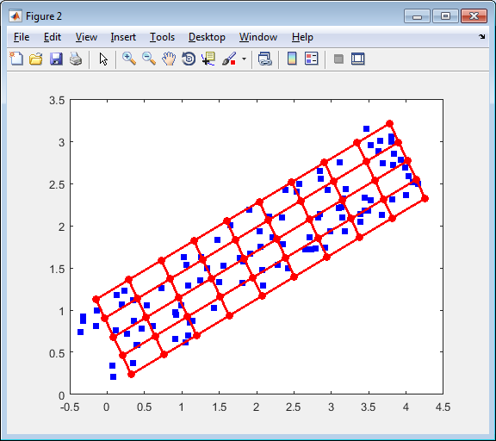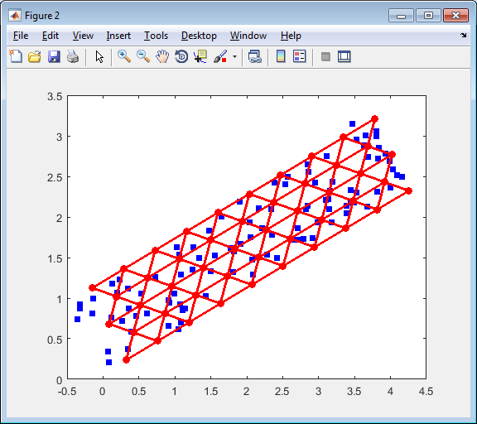

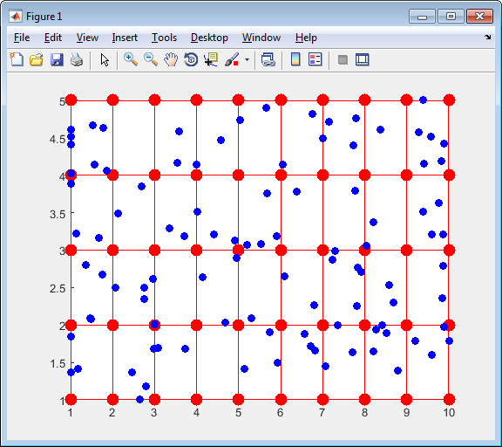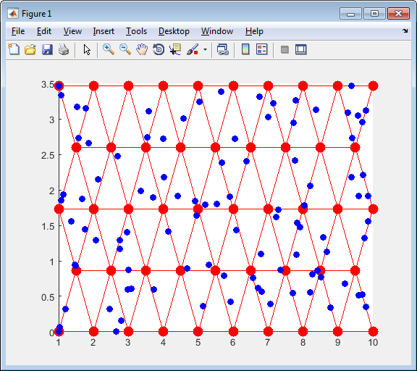

Figure 8. Examples of data points projection to the nearest face: top row contains graphs in the original space and bottom row contains corresponding graphs in the internal coordinates; left column presents the rectangular 2D map and right column presents the triangular 2D map.

# Fraction of variance unexplained

Fraction of Variance Unexplained (FVU) [2] is usually considered as measure of goodness of fit for specified statistical model. The less FVU means the better model. In this package FVU is unexplained variance divided by ‘zero model’ variance. This measure is closely related with coefficient of determination $R^{2}$ [2]. This measure usually applied to models with one dependent variable. In our case we consider multidimensional data and variance is not a scalar value. For such cases the sum of variances is widely used [3, 4]. Let us consider the $n$ dimensional data space. If we consider each coordinate as random variable then for $i$ th coordinate we have

|  |  |
| --- | --- |
| $$V_{i}=\frac{1}{N-1}\sum_{j=1}^{N}{{\left(d_{ij}-\overline{d_{i}}\right)}^{2}},d_{i}=\frac{1}{N}\sum_{j=1}^{N}{d_{ij}},$$ | (13) |

where $N$ is number of data points. The full variance is

|  |  |
| --- | --- |
|  | (14) |

We can see that (14) defines variance as average squared distance between data points and mean point which is considered as zero model. We generalize (14) for arbitrary model $m$ as

|  |  |
| --- | --- |
|  | (15) |

where $d_{j}^{m}$ is the approximation of point $d_{j}$ by the model $m$. FVU can be calculated as

|  |  |
| --- | --- |
|  | (16) |

There are several values of FVU can be considered for EM and SOM: this value is depends from the type of used projection (see “Projection data points onto map”). It is preferable to consider projection onto face for two dimensional maps and onto edges for one dimensional map. However, possibility to project onto face is optional and part of map geometries does not provide it. As a result we consider projection onto edges as default method for FVU calculation.

Important notion: it is necessary to stress that FVU is not the function which is minimized during the map fitness for EM and SOM.

# Map extrapolation

Most mapping techniques, includes SOM and Elastic maps, have many border points (see, for example, Figure 22 and Figure 23). This effect is result of map fitting procedures. The simplest way to resolve this problem is to add one or more map fragments outside the map. Examples of one layer extension for standard mars are presented in Figure 9.

a

b

c

Figure 9. Extension of standard maps: black is old map, red shows added edges, and blue shows new border

## Extension for OneDMap

In this map we add two edges: at the beginning and at the end. Both edges are replicas of the first and last edges, correspondingly.

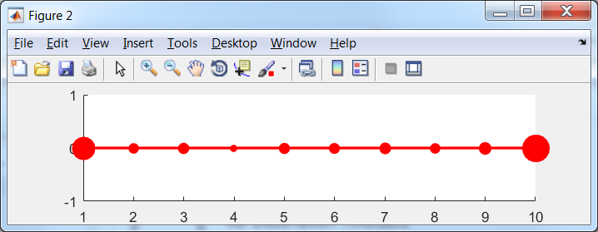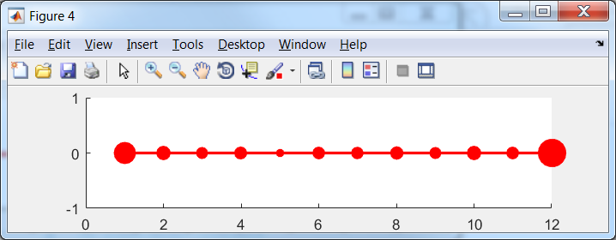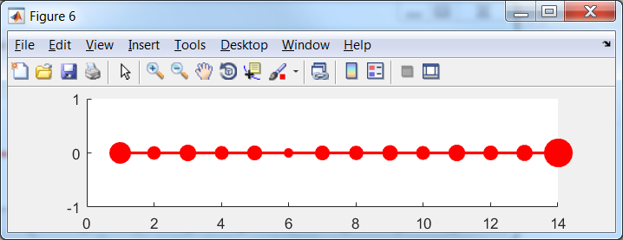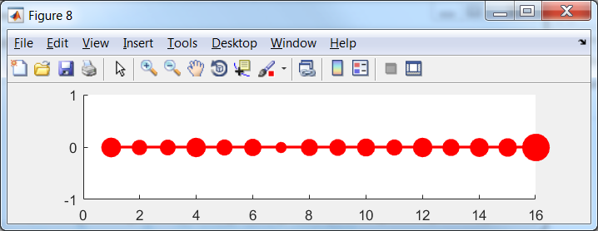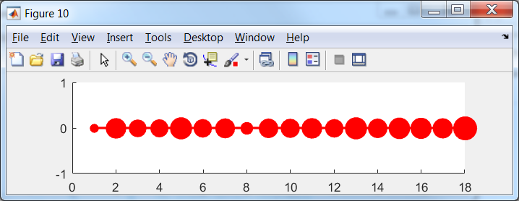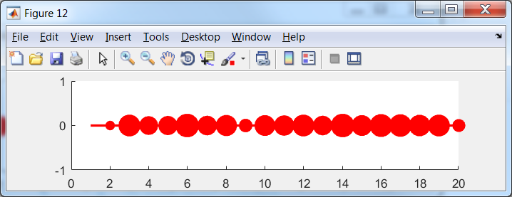

Figure 10. Extension of OneDMap for EM(map, data, 'stretch', 0.01, 'bend', 0.1, 'potential', @LLog, 'Number_of_intervals', 5); left is original map and then each next map have one more ribbon

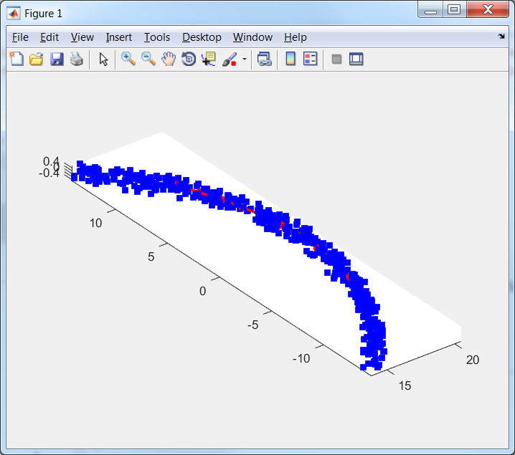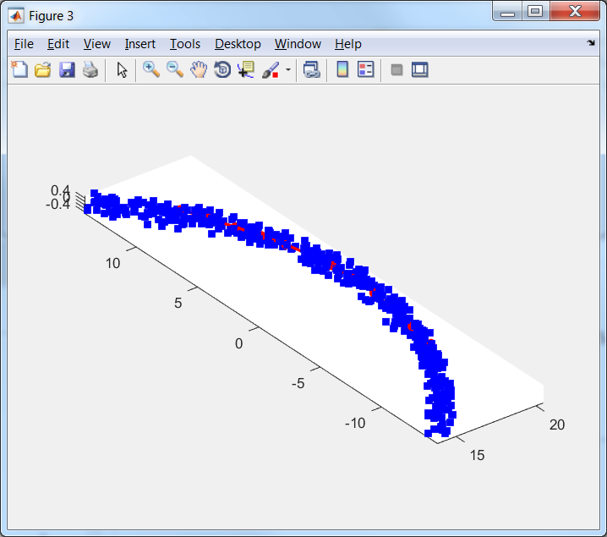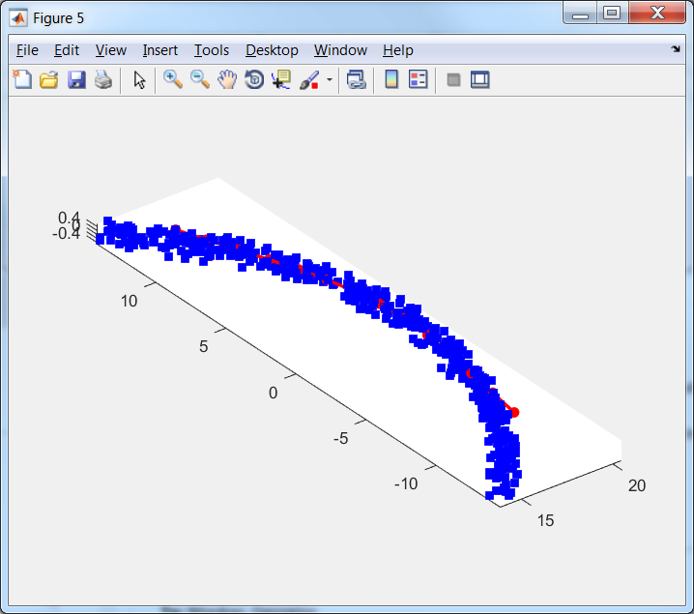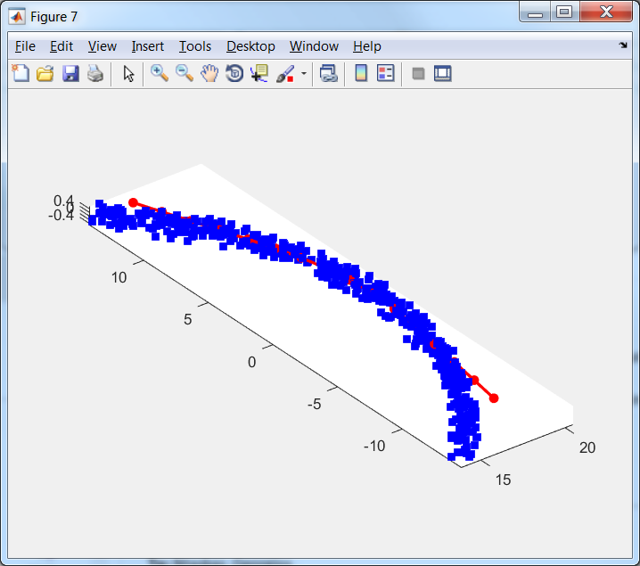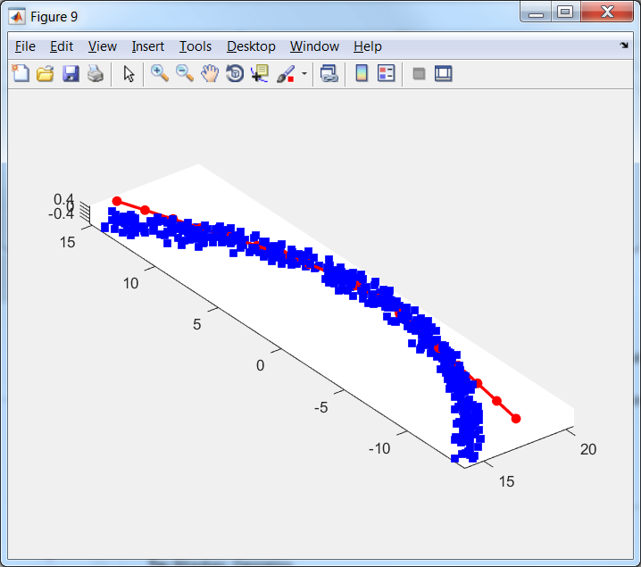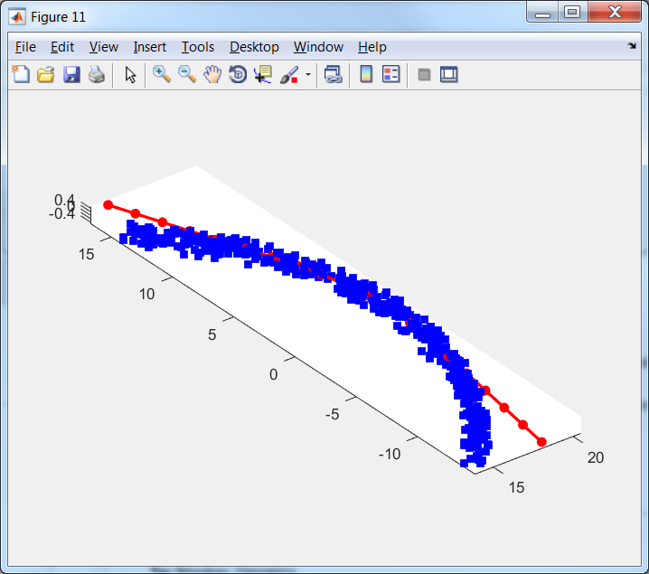

Figure 11. Extension of OneDMap for EM(map, data, 'stretch', 0.01, 'bend', 0.1, 'potential', @LLog, 'Number_of_intervals', 5); left is original map and then each next map have one more ribbon

As we can see in the original map fraction of points at the border case is considerable but then decreased. Moreover the last extension can be considered as unnecessary.

Table 1. Fraction of border cases for example of OneDMap

|  |  |  |  |  |  |  |
| --- | --- | --- | --- | --- | --- | --- |
| Number of extension | 0 | 1 | 2 | 3 | 4 | 5 |
| Fraction of border cases | 0.574 | 0.446 | 0.330 | 0.218 | 0.096 | 0.022 |

## Extension for rect2DMap

We train map by Elastic map with following arguments: EM(map, data, 'stretch', 0.001, 'bend', 0.1, 'potential', @LLog, 'Number_of_intervals', 5). This method produce not very good map but this map is appropriate to use extension.

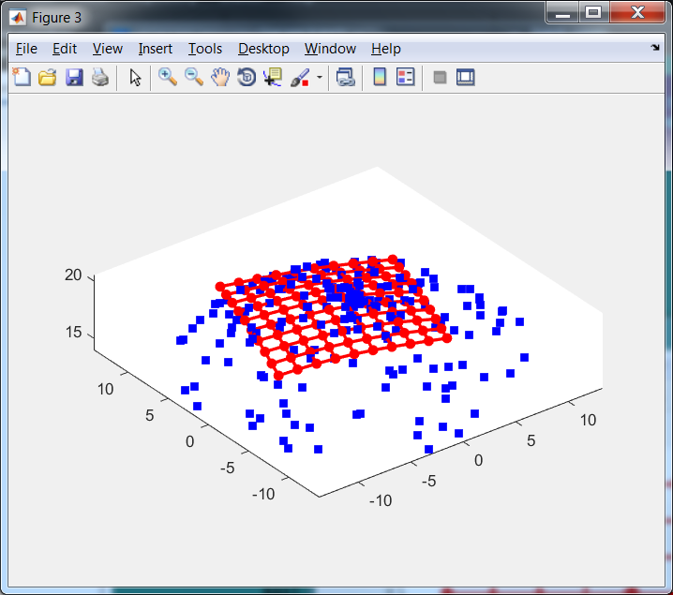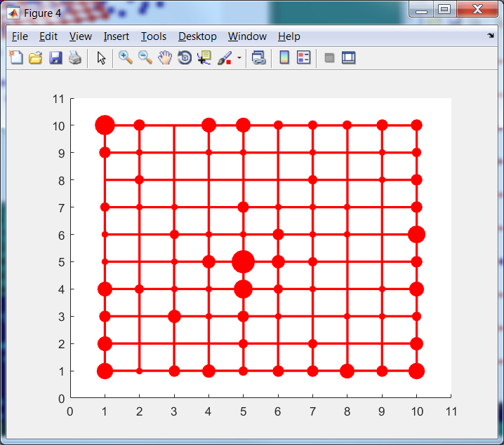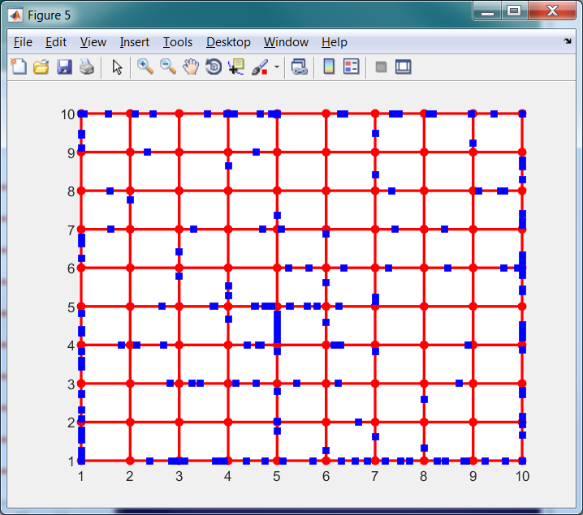

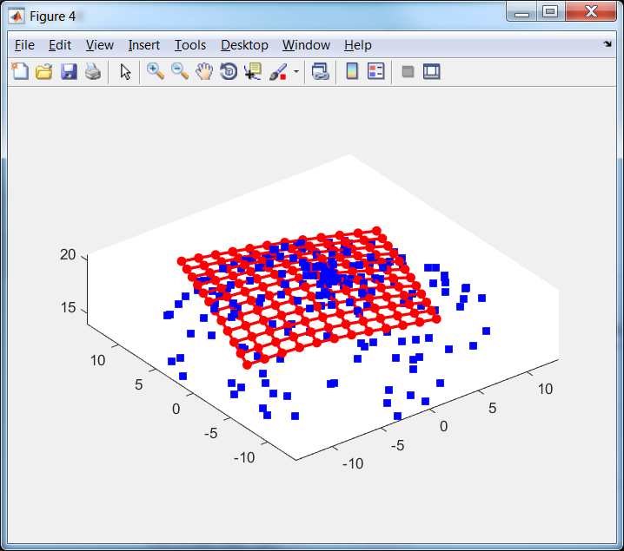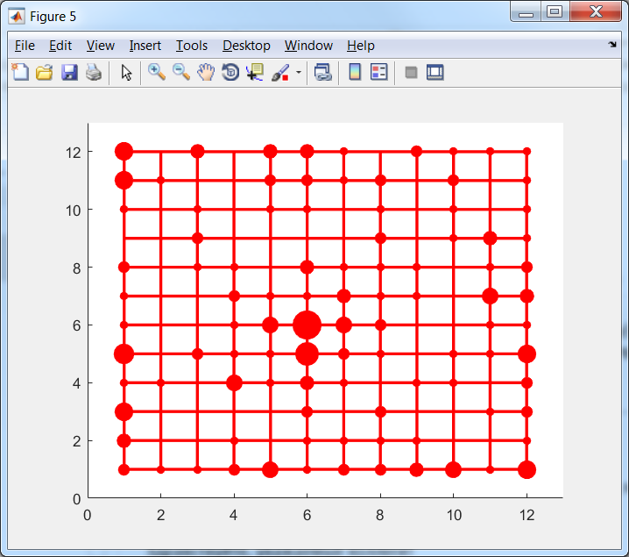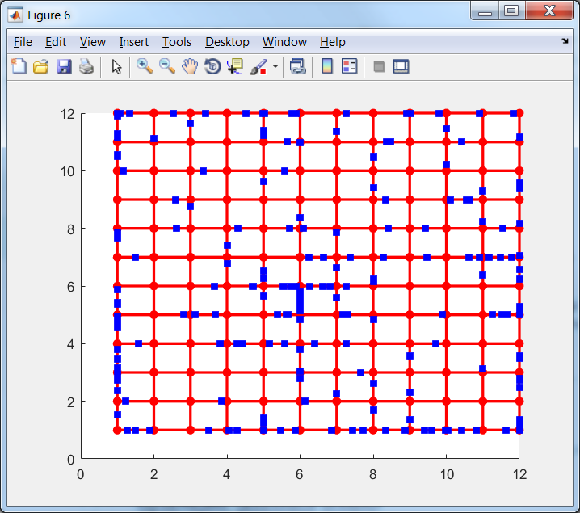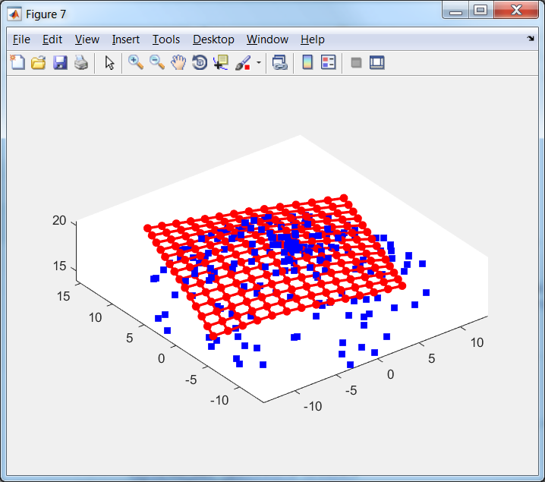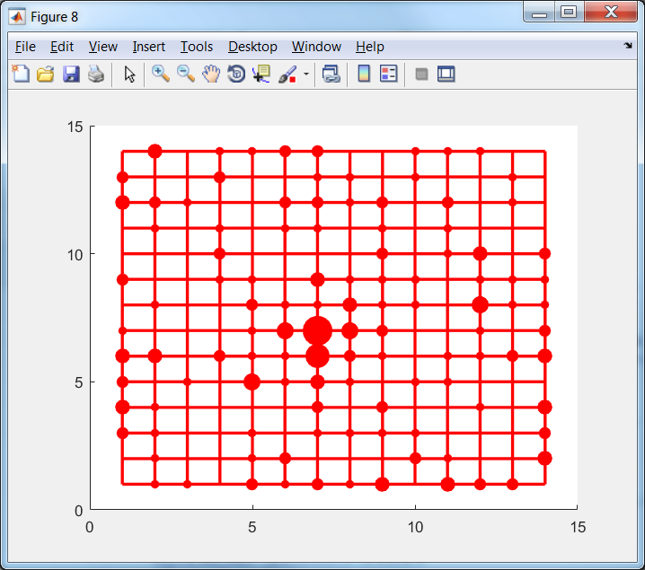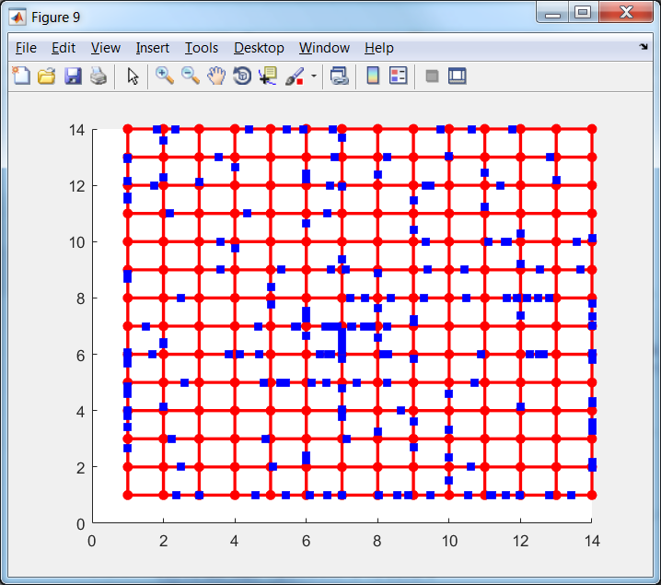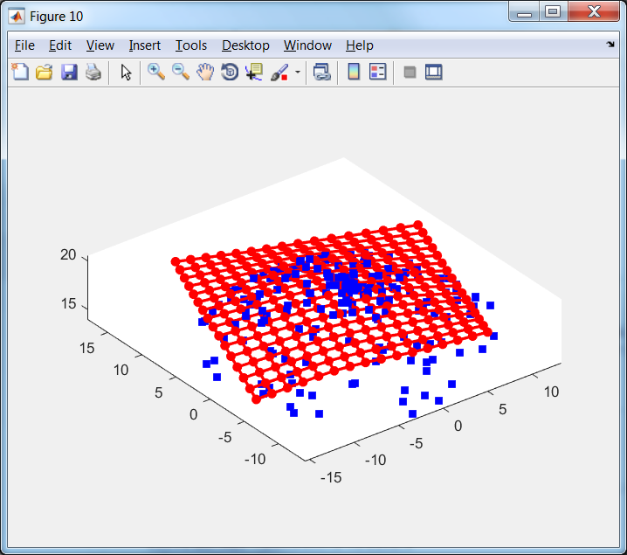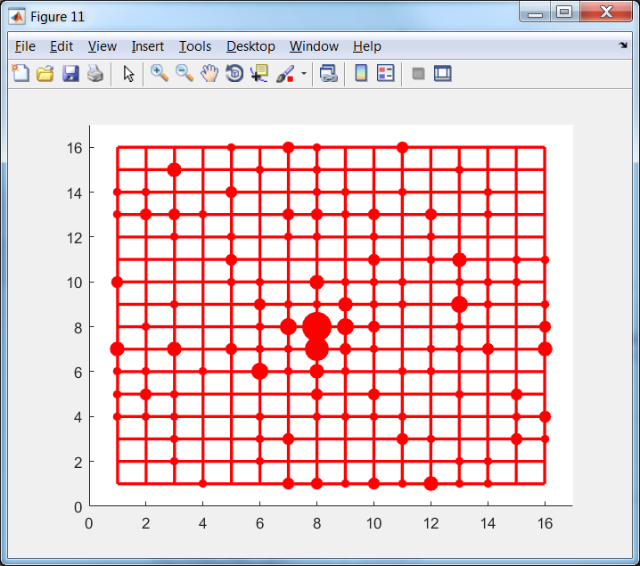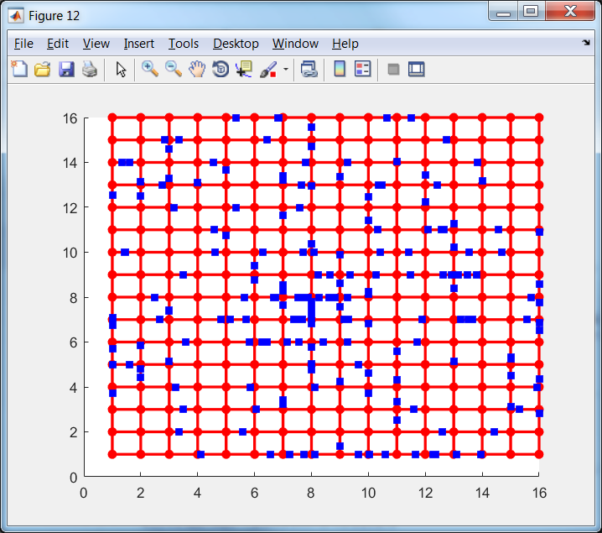 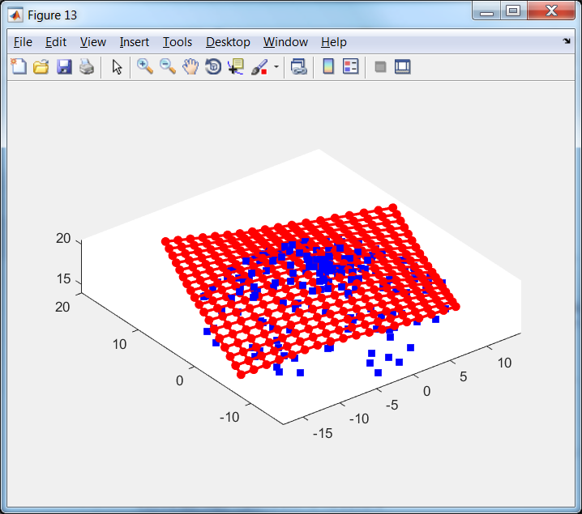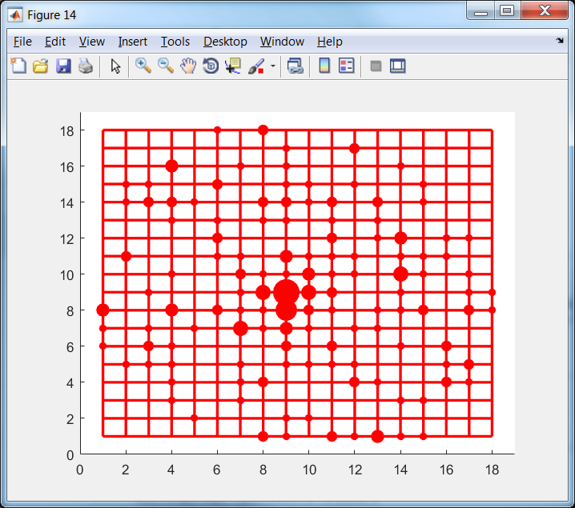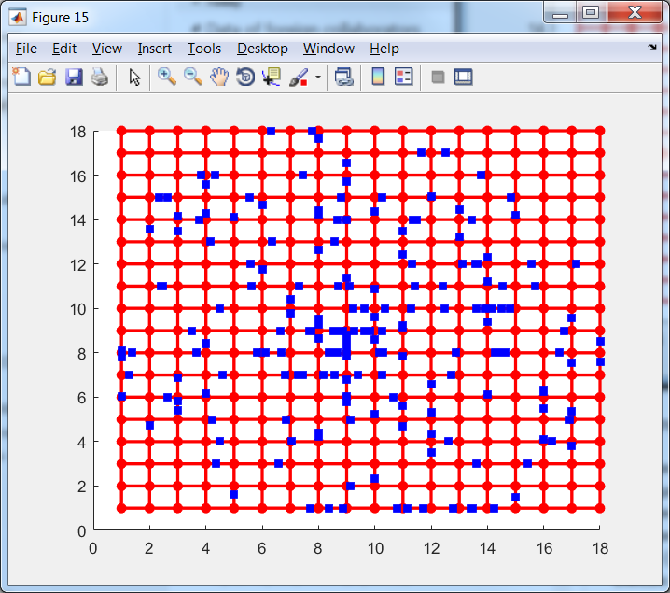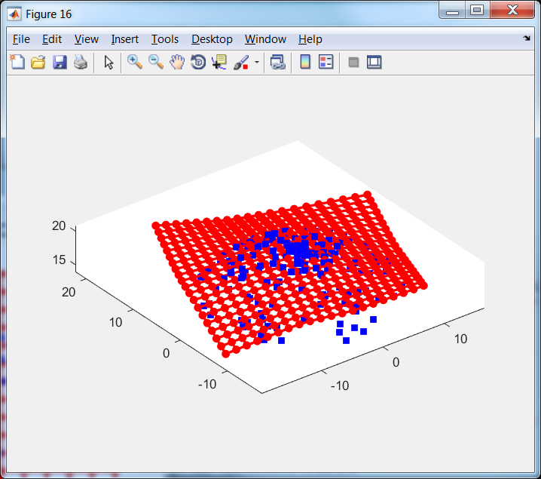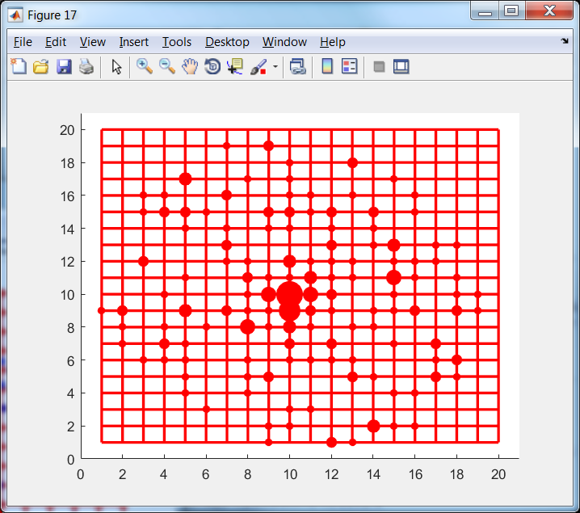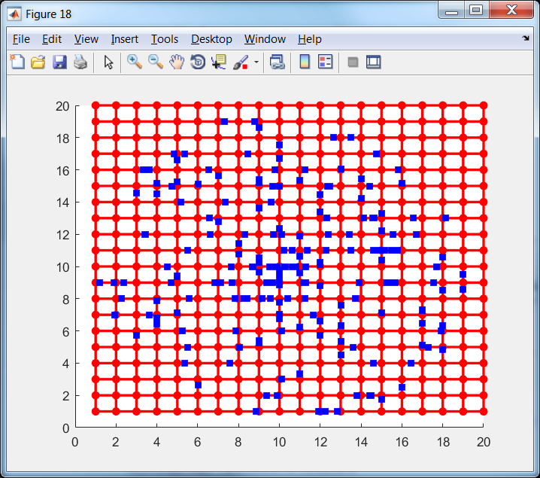

Figure 12. Extension of rect2DMap in 3D projection (left), in the internal coordinates with projection onto node (centre) and with projection onto edges (right)

Fractions of border cases are presented in Table 2.

Table 2. Fraction of border cases for example of rect2DMap

|  |  |  |  |  |  |  |
| --- | --- | --- | --- | --- | --- | --- |
| Number of extension | 0 | 1 | 2 | 3 | 4 | 5 |
| Fraction of border cases | 0.595 | 0.460 | 0.325 | 0.200 | 0.105 | 0.025 |

## Extension for tri2DMap

We train map by Elastic map with following arguments: EM(map, data, 'stretch', 0.001, 'bend', 0.1, 'potential', @LLog, 'Number_of_intervals', 5). This method produce not very good map but this map is appropriate to use extension.

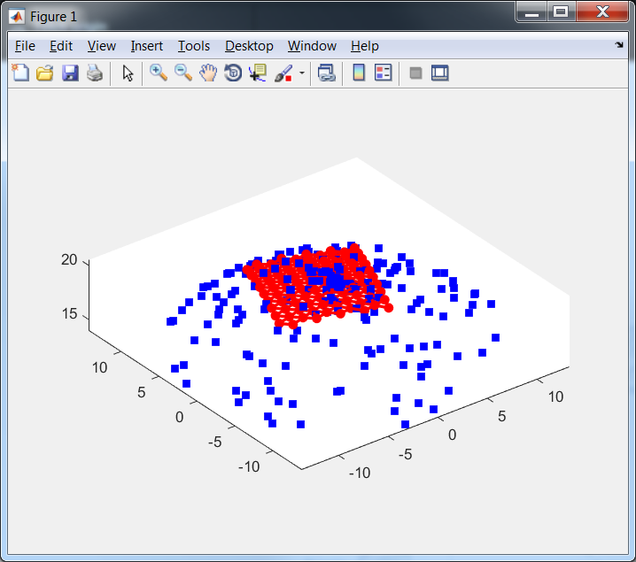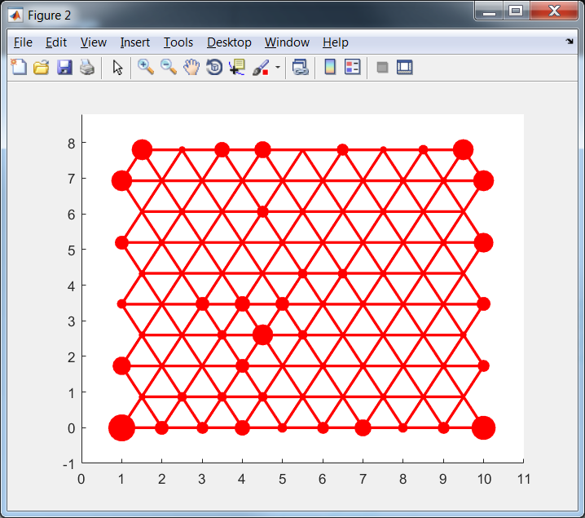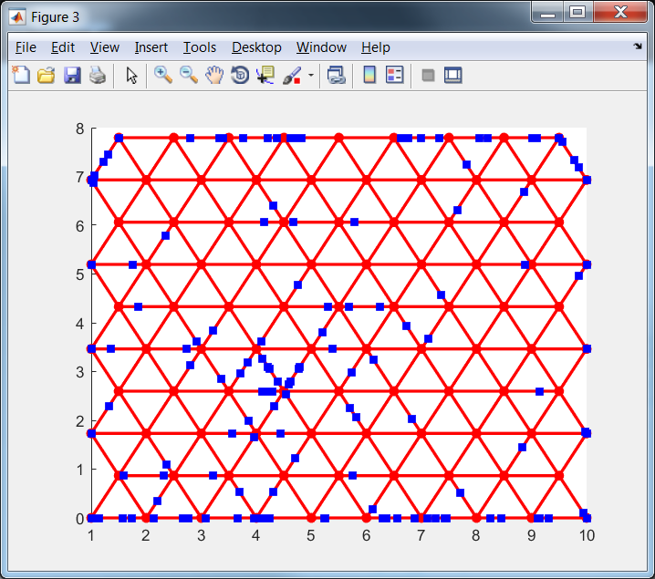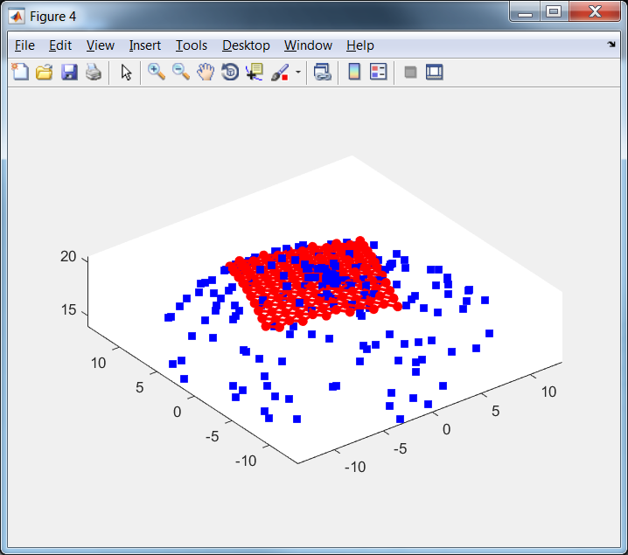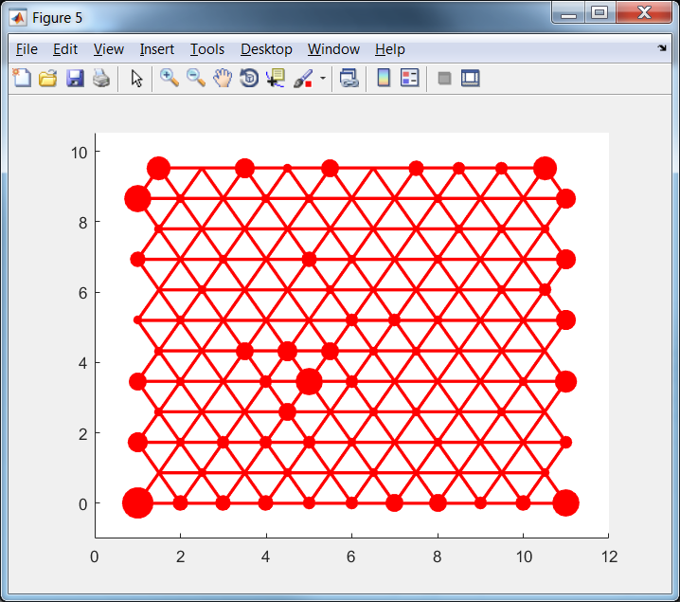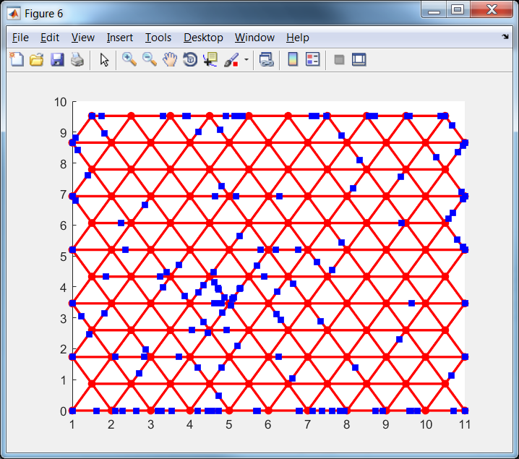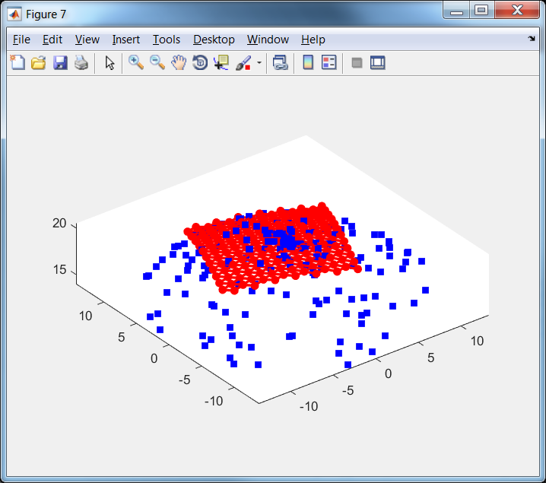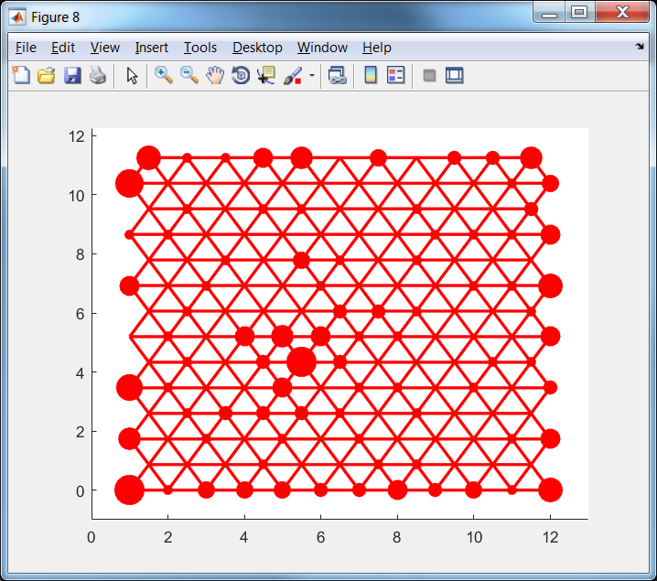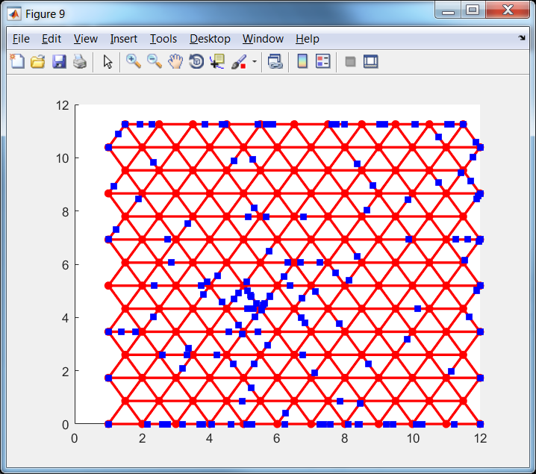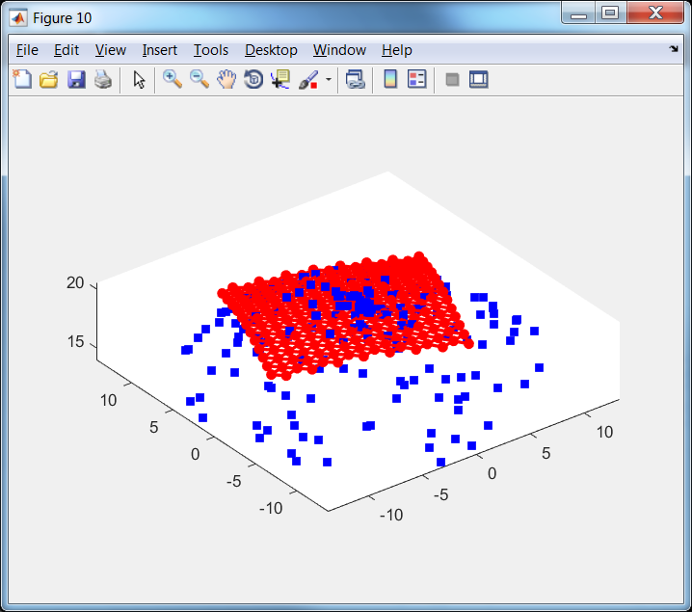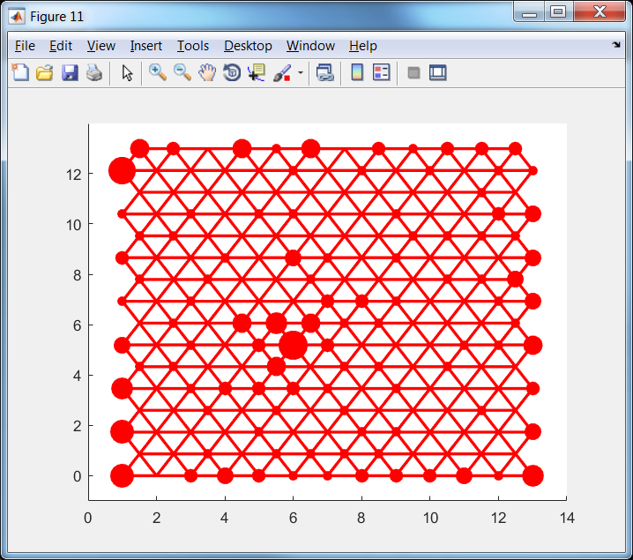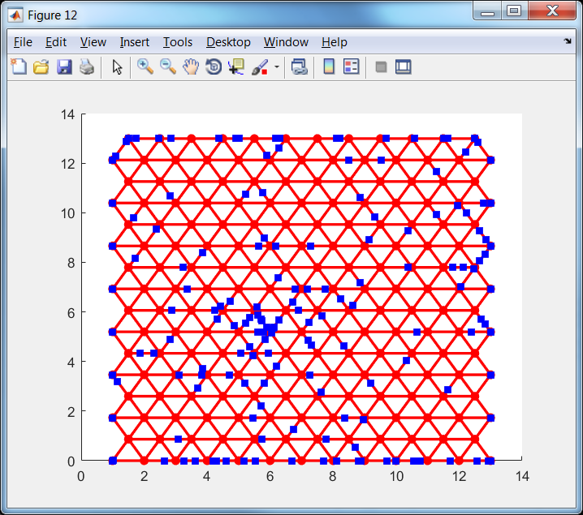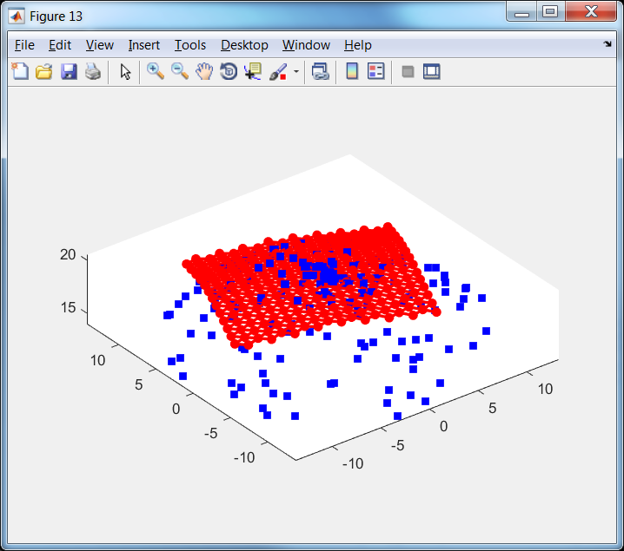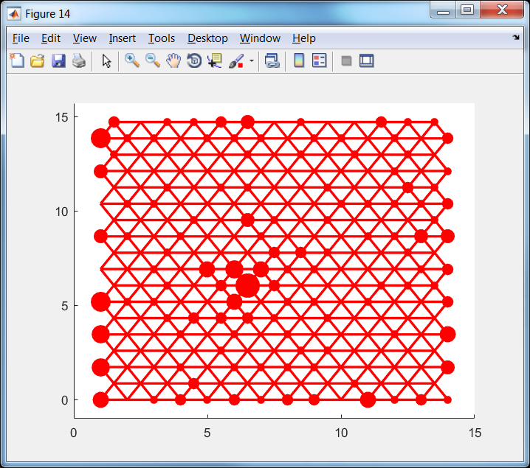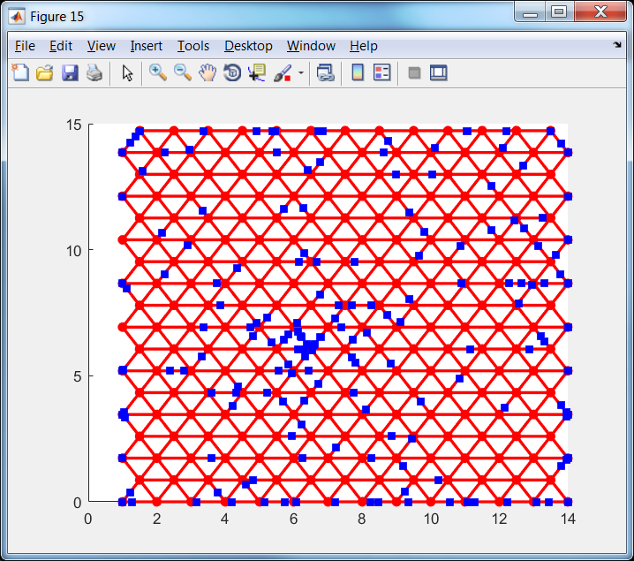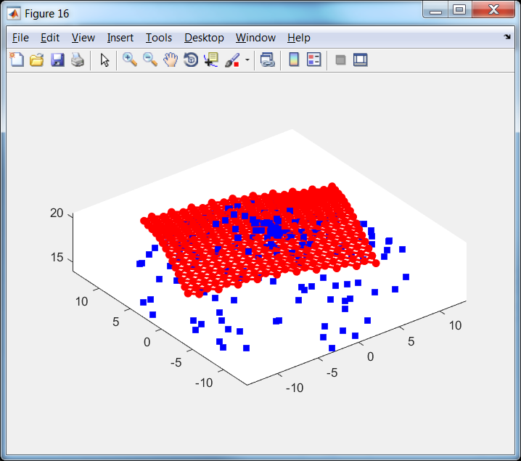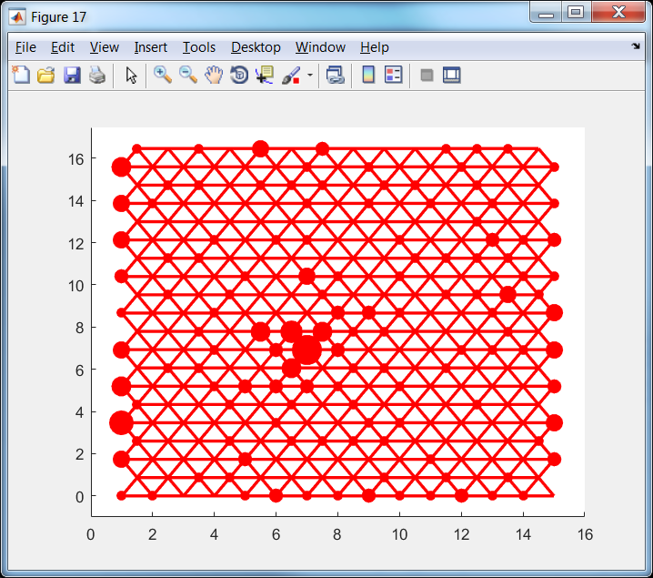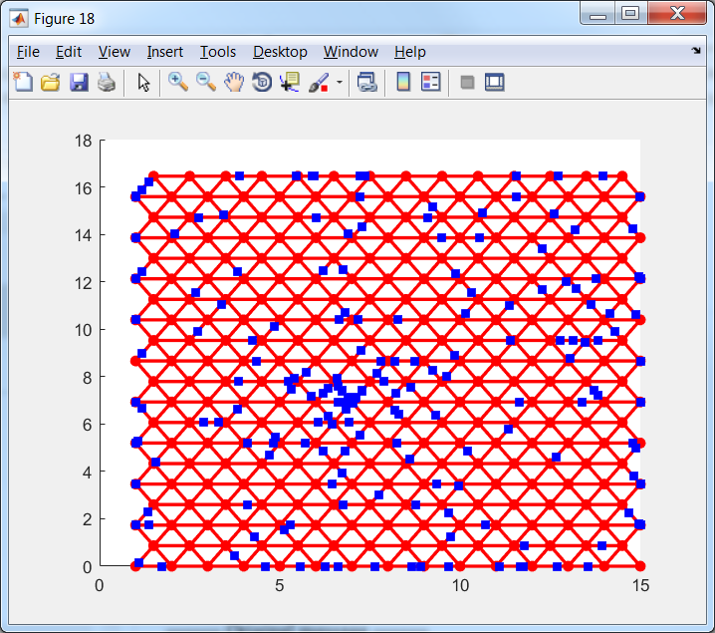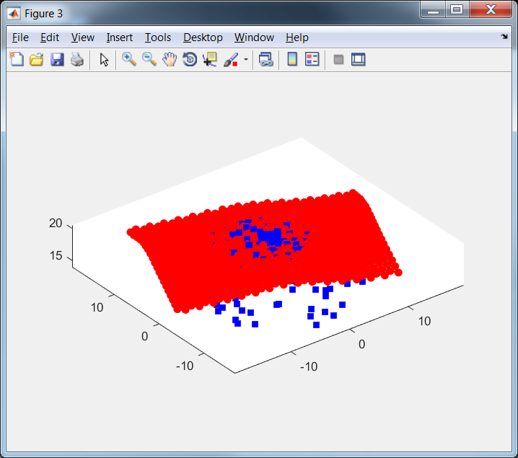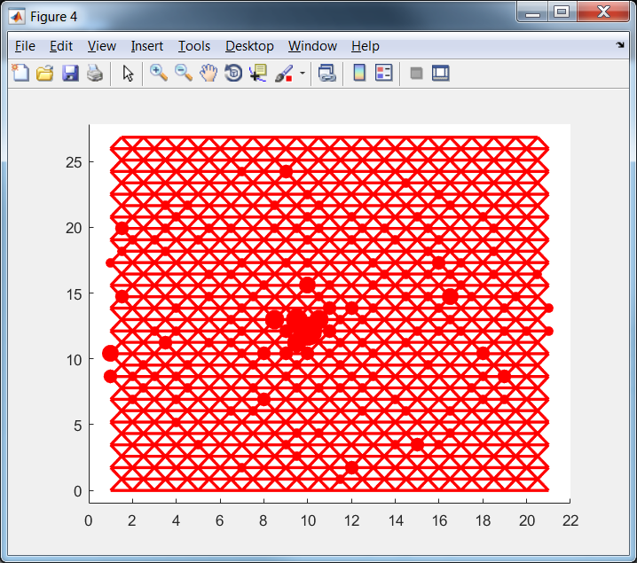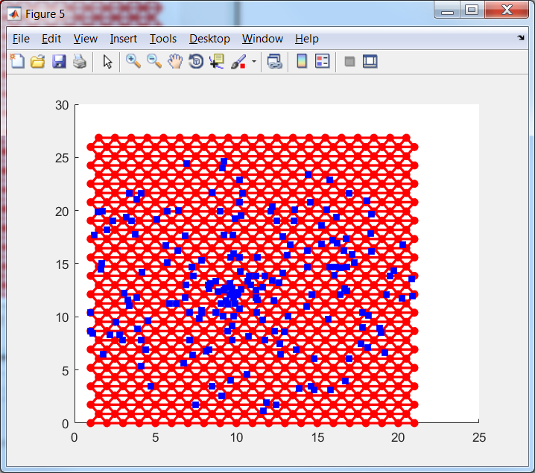

Figure 13. Extensions of tri2DMap in 3D projection (left), in the internal coordinates with projection onto node (centre) and with projection onto edges (right)

Fractions of border cases are presented in Table 3.

Table 3. Fraction of border cases for example of tri2DMap

|  |  |  |  |  |  |  |  |  |  |  |  |  |
| --- | --- | --- | --- | --- | --- | --- | --- | --- | --- | --- | --- | --- |
| Number of extension | 0 | 1 | 2 | 3 | 4 | 5 | 6 | 7 | 8 | 9 | 10 | 11 |
| Fraction of border cases | 0.69 | 0.62 | 0.58 | 0.50 | 0.42 | 0.36 | 0.29 | 0.22 | 0.14 | 0.10 | 0.08 | 0.04 |

It is very intrigue that for triangular map number of extension to provide the same fraction of border cases is significantly greater. This is effect of different extension rate in different directions: the first map in Figure 13 has 10 rows and 10 nodes in the bottom row but the last map has 32 rows and 21 nodes in the bottom row.

# EM (Elastic map)

EM is function which fit parameters of elastic map. Elastic map is introduced in paper [5] and detailed description is contained in [6]. The main idea of this approach is to search map as solution of optimization problem.

## Elastic energy

Let us have set of data points $d_{i},i=1,…,N$ in $D$ dimensional space and map which contains $K$ nodes $n_{i},i=1,…,K$ which connected by edges $e_{i}=\left(e_{i0},e_{i1}\right),i=1,…,E$, where $e_{ij}$ are number of nodes. Edges form ribs $r_{i}=\left(r_{i0},r_{i1},r_{i2}\right), i=1,…, R$, where $r_{ij}$ are number of nodes.

Our goal is to find map which (i) accurately approximate data and (ii) is smooth. To formalize the first requirement we can consider projection of each data point into nearest node and require the minimization of sum of squared distances between data points and projection of data points:

|  |  |
| --- | --- |
|  | (17) |

where $n(d)$ is the node which is nearest to point $d$.

To formalize the requirement for map to be ‘smooth’ we can penalize disturbance of smoothness. Let us use metaphor of elasticity: we have to forbid ‘big’ tension of edges and ‘big’ bending of ribs. For the first purpose we introduce stretching energy term:

|  |  |
| --- | --- |
|  | (18) |

where $λ>0$ is stretching modulo. To prevent the big bending we introduce bending energy term:

|  |  |
| --- | --- |
|  | (19) |

where $μ>0$ is bending modulo. Combination of data approximation term (17), stretching term (18) and bending term (19) forms elastic energy of map:

|  |  |
| --- | --- |
| $$U=U_{d}+U_{e}+U_{r}.$$ | (20) |

To find the best map we need to find minimum of function (20). Minimum of function (20) can be found by two step procedure

1. Association. Find the nearest nodes $n(d)$ for each point $d$ for fixed nodes.
2. Minimization. Minimize energy (20) for fixed set of $n(d)$.

These two steps are repeated several times until the set of $n(d)$ for two association steps become the same. It simple to prove that algorithm converges. The energy (20) is nonnegative. Let us consider the values of energy for two steps. Let us have value $V_{0}$ and set $n(d)$ after the association step. The following step is minimization of energy. It means that value $V_{1}$ of energy after this step can be less or equal to $V_{0}$. If $V_{1}=V_{0}$ then location of nodes does not change and set of new nearest nodes $n'(d)$ is the same. It means that algorithm converged. If $V_{1}<V_{0}$ then part of new nearest nodes $n'(d)$ is different. Let us compare the energy value $V_{2}$ after the finding of new set of nearest nodes $n'(d)$ with $V_{1}$. Step of association of data points with nearest nodes does not change terms $U_{e}$ and $U_{r}$. It means that difference between $V_{1}$ and $V_{2}$ is in the term $U_{d}$ only. Let us select data point $d$ such that $n\left(d\right)≠n^{'}\left(d\right)$. Since $n'(d)$ is nearest node to the point $d$ we have ${\left\|d-n\left(d\right)\right\|}^{2}>{\left\|d-n'\left(d\right)\right\|}^{2}.$ The same inequality holds for all $d$ such that $n\left(d\right)≠n^{'}\left(d\right)$. For all data points $d$ such that $n\left(d\right)=n^{'}\left(d\right)$ we have equality ${\left\|d-n\left(d\right)\right\|}^{2}={\left\|d-n'\left(d\right)\right\|}^{2}$. $V_{1}$ contains summands ${\left\|d-n\left(d\right)\right\|}^{2}$ and $V_{2}$ contains summands ${\left\|d-n^{'}\left(d\right)\right\|}^{2}$. It means that $V_{2}<V_{1}$ if at least for one data point $d$ we have $n\left(d\right)≠n^{'}\left(d\right)$. If there is no points which change nearest node then algorithm converged. Finally we proved that for each step of algorithm value of energy becomes less or equal to the value of energy before this step and equality of energy values before and after step means that algorithm converged. Value of energy is restricted by zero. Number of possible sets $n\left(d\right)$ is finite. It means that algorithm will be stopped after finite steps.

Step of data points association with nearest nodes requires calculation of distances between each data point and each nodes and selection of minimum for each data point.

The minimum of energy for fixed association can be found by differentiation of energy (20) with respect to each $j$ coordinate of each $i$ node:

|  |  |
| --- | --- |
| $$\frac{∂U}{∂n_{ij}}=\frac{∂U_{d}}{∂n_{ij}}+\frac{∂U_{e}}{∂n_{ij}}+\frac{∂U_{r}}{∂n_{ij}}=0.$$ | (21) |

Let us consider each term separately. For data approximation term we have

|  |  |
| --- | --- |
| $$\frac{∂U_{d}}{∂n_{ij}}=\frac{2}{N}\sum_{\begin{aligned}k=1 \\ n\left(d_{k}\right)=n_{i}\end{aligned}}^{N}{\left(n_{ij}-d_{kj}\right)}.$$ | (22) |

For stretching term we have

|  |  |
| --- | --- |
| $$\frac{∂U_{e}}{∂n_{ij}}=2λ\sum_{\begin{aligned}k=1 \\ e_{k0}=i\end{aligned}}^{E}{\left(n_{ij}-n_{e_{k1}j}\right)}+2λ\sum_{\begin{aligned}k=1 \\ e_{k1}=i\end{aligned}}^{E}{\left(n_{ij}-n_{e_{k0}j}\right)}.$$ | (23) |

For bending term we have

|  |  |
| --- | --- |
| $$\frac{∂U_{r}}{∂n_{ij}}=2μ\sum_{\begin{aligned}k=1 \\ r_{k0}=i\end{aligned}}^{R}{\left(n_{ij}-2n_{r_{k1}j}+n_{r_{k2}j}\right)}-4μ\sum_{\begin{aligned}k=1 \\ r_{k1}=i\end{aligned}}^{R}{\left(n_{r_{k0}j}-2n_{ij}+n_{r_{k2}j}\right)}+2μ\sum_{\begin{aligned}k=1 \\ r_{k2}=i\end{aligned}}^{R}{\left(n_{r_{k0}j}-2n_{r_{k1}j}+n_{ij}\right)}$$ | (24) |

We can see that equation (21) can be written as system of linear algebraic equations

|  |  |
| --- | --- |
| $$\left(A+λB+μC\right)n=F,$$ | (25) |

where $K$ by $K$ matrices $A,B,C$ correspond to data approximation, stretching and bending terms correspondingly, $n$ is matrix each row of which is coordinates of one node and $F$ is matrix with $K$ rows and $D$ columns. It is important that matrices $B$ and $C$ are data independent and can be calculated once. Matrix $A$ is data dependent and must be recalculated after each association step. All coordinates of nodes are independent.

Let us denote $N_{i}$ the number of data points which are associated with node $n_{i}$. Then we can write matrix $A$:

|  |  |
| --- | --- |
| $$a_{ij}=0,∀i≠j,a_{ii}=\frac{N_{i}}{N}.$$ | (26) |

Matrix $F$ can be written as

|  |  |
| --- | --- |
| $$f_{ij}=\frac{1}{N}\sum_{\begin{aligned}k=1 \\ n\left(d_{k}\right)=n_{i}\end{aligned}}^{N}{d_{kj}}.$$ | (27) |

Matrix $B$ can be calculated iteratively. Put $b_{ij}=0,∀i,j=1,…,K$. For each edge $e_{i}$ perform modification of matrix:

$$b_{e_{i0}e_{i0}}→b_{e_{i0}e_{i0}}+1,$$

$$b_{e_{i0}e_{i1}}→b_{e_{i0}e_{i1}}-1,$$

$$b_{e_{i1}e_{i0}}→b_{e_{i1}e_{i0}}-1,$$

$$b_{e_{i1}e_{i1}}→b_{e_{i1}e_{i1}}+1.$$

Matrix $C$ can be calculated iteratively. Put $c_{ij}=0,∀i,j=1,…,K$. For each rib $r_{i}$ perform modification of matrix:

$$c_{r_{i0}r_{i0}}→c_{r_{i0}r_{i0}}+1,$$

$$c_{r_{i0}r_{i1}}→c_{r_{i0}r_{i1}}-2,$$

$$c_{r_{i0}r_{i2}}→c_{r_{i0}r_{i2}}+1,$$

$$c_{r_{i1}r_{i0}}→c_{r_{i1}r_{i0}}-2,$$

$$c_{r_{i1}r_{i1}}→c_{r_{i1}r_{i1}}+4,$$

$$c_{r_{i1}r_{i2}}→c_{r_{i1}r_{i2}}-2,$$

$$c_{r_{i2}r_{i0}}→c_{r_{i2}r_{i0}}+1,$$

$$c_{r_{i2}r_{i1}}→c_{r_{i2}r_{i1}}-2,$$

$$c_{r_{i2}r_{i2}}→c_{r_{i2}r_{i2}}+1.$$

## Weighted version

Data points can have weights $w_{i}$. In this case data term of energy has kind:

|  |  |
| --- | --- |
|  | (28) |

Derivative of this function is

|  |  |
| --- | --- |
| $$\frac{∂U_{dw}}{∂n_{ij}}=\frac{2}{\sum_{k=1}^{N}{w_{k}}}\sum_{\begin{aligned}k=1 \\ n\left(d_{k}\right)=n_{i}\end{aligned}}^{N}{w_{k}\left(n_{ij}-d_{kj}\right)}.$$ | (29) |

Matrices $A$ and $F$ can be rewritten in the form

|  |  |
| --- | --- |
| $$a_{ij}=0,∀i≠j,a_{ii}=\frac{1}{\sum_{k=1}^{N}{w_{k}}}\sum_{\begin{aligned}k=1 \\ n\left(d_{k}\right)=n_{i}\end{aligned}}^{N}{w_{k}}.$$ | (30) |
| $$f_{ij}=\frac{1}{\sum_{k=1}^{N}{w_{k}}}\sum_{\begin{aligned}k=1 \\ n\left(d_{k}\right)=n_{i}\end{aligned}}^{N}{{w_{k}d}_{kj}}.$$ | (31) |

## $λ$ and $μ$ choice

Selection of appropriate values of $λ$ and $μ$ is very important problem.

It looks like reasonable to have the same stretching energy for maps with different number of nodes. Let us consider map with one edge of length $s$. Stretching energy of this map is

$$U_{e}^{1}=λs^{2}.$$

Let us split this edge into $m$ smaller equal edges. Then we can write

$$U_{e}^{m}=λ_{m}\sum_{i=1}^{m}{{\left(\frac{s}{m}\right)}^{2}}=mλ_{m}{\left(\frac{s}{m}\right)}^{2}=\frac{λ_{m}}{m}s^{2}=\frac{λ_{m}}{mλ}U_{e}^{1}.$$

Since we want to have the same energy we can write:

$$U_{e}^{1}=U_{e}^{m}=\frac{λ_{m}}{m}\frac{U_{e}^{1}}{λ}⇒λ_{m}=mλ.$$

This means that if we define stretch modulo for one fragment as $λ$ then for chain of $m$ edges we have to use modulo $mλ$.

Let us require to have the same bending modulo for maps with different number of nodes. Let us consider two maps for the circle (see Figure 14).

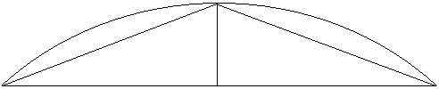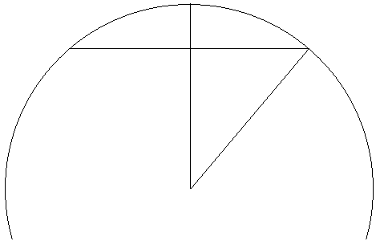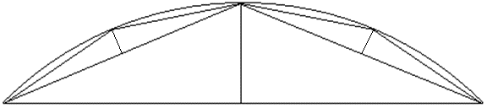

$$R$$

$$1$$

$$1$$

$$1$$

$$h$$

$$h$$

$$h$$

$$R-h$$

$$α/2$$

$$h_{4}$$

a

b

c

Figure 14. Two maps for fragment of circle with two (a and c) and four (b) edges

Let us denote the coordinates of three points in the left figure as $\left(-1,0\right), \left(0,h\right), (1,0)$. In this case bending elastic energy is

$$U_{r}^{1}=μ_{2}{\left\|n_{r_{i0}}-2n_{r_{i1}}+n_{r_{i2}}\right\|}^{2}=μ_{2}\left({\left(1-2×0+\left(-1\right)\right)}^{2}+{\left(0-2h+0\right)}^{2}\right)=4μ_{2}h^{2}.$$

Let us calculate the altitude of left (right) triangle in the right figure. To calculate it we can use formula of length of chord:

$$g=2R\sin{\frac{α}{2}},$$

where $α$ is central angle for chord and $R$ is radius. For chord from the first point to the last point we can write

$$2R\sin{\frac{α}{2}}=2.$$

Then we can write $R-R\cos{\frac{α}{2}}=h$. Since we know that angle $α$ is positive and small enough we can find $R$ and $α$:

$$R^{2}\sin^{2}{\frac{α}{2}}+R^{2}\cos^{2}{\frac{α}{2}}=R^{2}=1+{\left(R-h\right)}^{2}.$$

$$R^{2}=1+R^{2}-2hR+h^{2}.$$

$$R=\frac{h^{2}+1}{2h}.$$

Required altitude can be found as

$$h_{4}=R-R\cos{\frac{α}{4}}.$$

We also know that

$$\cos{\frac{θ}{2}}=\sqrt{\frac{1+\cos{θ}}{2}}.$$

Now we can calculate

$$h_{4}=R\left(1-\cos{\frac{α}{4}}\right)=R\left(1-\sqrt{\frac{1+\cos{\frac{α}{2}}}{2}}\right)=R\left(1-\sqrt{\frac{1+\frac{R-h}{R}}{2}}\right)=R\left(1-\sqrt{\frac{2R-h}{2R}}\right)=R\left(1-\sqrt{1-\frac{h}{2R}}\right)=\frac{h^{2}+1}{2h}\left(1-\sqrt{1-\frac{h}{2\frac{h^{2}+1}{2h}}}\right)=\frac{h^{2}+1}{2h}\left(1-\sqrt{\frac{1}{h^{2}+1}}\right)=\frac{h^{2}+1}{2h}-\sqrt{{\left(\frac{h^{2}+1}{2h}\right)}^{2}\frac{1}{h^{2}+1}}=\frac{h^{2}+1}{2h}-\sqrt{\frac{h^{2}+1}{{4h}^{2}}}=\frac{h^{2}+1-\sqrt{h^{2}+1}}{2h}.$$

We know that for any reasonable situations $h≪1$. This means that we can estimate $\sqrt{h^{2}+1}≈1.$ Now we can write

$$h_{4}≈\frac{h^{2}+1-1}{2h}=\frac{h}{2}.$$

For the second map we have three equal summands in bending energy:

$$U_{r}^{2}=3×4μ_{4}h_{4}^{2}=3×4μ_{4}\frac{h^{2}}{4}=3μ_{4}h^{2}.$$

We want to have equal energies. This means

$$4μ_{2}h^{2}=3μ_{4}h^{2}⇒μ_{4}=\frac{4}{3}μ_{2}.$$

Let us generalise the last formula. First of all, formula $h_{2m}≈\frac{h_{m}}{2}$ is correct for all case of $h_{m}$ which is small relatively length of edge. Now let us calculate energies for chain of $m$ edges of equal length. This chain contains $m-1$ ribs and has energy

$$U_{r}^{m}=4\left(m-1\right)μ_{m}h_{m}^{2}.$$

Now let us split each edge in two equal edges by analogy of Figure 14. In this case we have chain with $2m-1$ ribs end energy

$$U_{r}^{2m}=4\left(2m-1\right)μ_{2m}h_{2m}^{2}=4\left(2m-1\right)μ_{2m}\frac{h_{m}^{2}}{4}=\left(2m-1\right)μ_{2m}h_{2m}^{2}.$$

Since we want to have equal energy we can write

$$U_{r}^{m}=U_{r}^{2m}⇒4\left(m-1\right)μ_{m}h_{m}^{2}=\left(2m-1\right)μ_{2m}h_{2m}^{2}⇒μ_{2m}=\frac{4\left(m-1\right)}{2m-1}μ_{m}.$$

## PQSQR for data

We have following values specified by user:

1. Set of intervals $\left[r_{i-1},r_{i}\right),i=1,…,p+1, r_{0}=0<r_{1}<…<r_{p}<r_{p+1}=∞.$
2. Majorante function $f\left(x\right)≥u\left(x\right).$

For each interval it is necessary to calculate coefficients of sub quadratic function with property $u\left(d\right)=\{a_{q}d^{2}+b_{q}, r_{q-1}≤d<r_{q}.$ To minimise difference of functions $u$ and $f$ under condition $f\left(x\right)≥u\left(x\right)$ it is necessary to put $u\left(r_{i}\right)=f(r_{i})$.

Let us calculate coefficients for arbitrary interval $q$:

$$\left\{\begin{matrix}u\left(r_{q-1}\right)=f\left(r_{q-1}\right) \\ u\left(r_{q}\right)=f\left(r_{q}\right)\end{matrix}\right.⇒\left\{\begin{matrix}a_{q}r_{q-1}^{2}+b_{q}=f\left(r_{q-1}\right) \\ a_{q}r_{q}^{2}+b_{q}=f\left(r_{q}\right)\end{matrix}\right.⇒\left\{\begin{matrix}a_{q}=\frac{f\left(r_{q-1}\right)-f\left(r_{q}\right)}{r_{q-1}^{2}-r_{q}^{2}} \\ b_{q}=f\left(r_{q}\right)-a_{q}r_{q}^{2}\end{matrix}\right..$$

For the border cases we have $a_{1}=\frac{f\left(0\right)-f\left(r_{1}\right)}{-r_{1}^{2}}=\frac{f\left(r_{1}\right)-f\left(0\right)}{r_{1}^{2}}, b_{1}=f\left(r_{1}\right){-a}_{1}r_{1}^{2}=f\left(r_{1}\right)-\frac{f\left(r_{1}\right)-f\left(0\right)}{r_{1}^{2}}r_{1}^{2}=f\left(0\right), a_{p+1}=0;b_{p+1}=f\left(r_{p}\right){-a}_{p+1}r_{p}^{2}=f\left(r_{p}\right).$

Ow we can rewrite data term (17) of energy function as

|  |  |
| --- | --- |
|  | (32) |

Let us calculate derivative

|  |  |
| --- | --- |
|  | (33) |

where $q_{j}$ is defined by inequality

$$r_{q_{j}-1}≤\left\|d_{j}-n_{i}\right\|<r_{q_{j}}.$$

Now we can rewrite matrix A as

|  |  |
| --- | --- |
| $$a_{ij}=0,∀i≠j,a_{ii}=\frac{1}{N}\sum_{\begin{aligned}k=1 \\ n\left(d_{k}\right)=n_{i}\end{aligned}}^{N}{a_{q_{k}}}.$$ | (34) |

Matrix $F$ can be written as

|  |  |
| --- | --- |
| $$f_{ij}=\frac{1}{N}\sum_{\begin{aligned}k=1 \\ n\left(d_{k}\right)=n_{i}\end{aligned}}^{N}{a_{q_{k}}d_{kj}}.$$ | (35) |

## Weighted PQSQ version

According to subsections “Weighted version” and “PQSQR for data” we can rewrite matrices $A$ and $F$ as

|  |  |
| --- | --- |
| $$a_{ij}=0,∀i≠j,a_{ii}=\frac{1}{\sum_{k=1}^{N}{w_{k}}}\sum_{\begin{aligned}k=1 \\ n\left(d_{k}\right)=n_{i}\end{aligned}}^{N}{w_{k}}a_{q_{k}}.$$ | (36) |
| $$f_{ij}=\frac{1}{\sum_{k=1}^{N}{w_{k}}}\sum_{\begin{aligned}k=1 \\ n\left(d_{k}\right)=n_{i}\end{aligned}}^{N}{{w_{k}a_{q_{k}}d}_{kj}}.$$ | (37) |

As we can see these formulas are almost the same as (30) and (31) with recalculation of weights as $w_{k}^{'}=w_{k}a_{q_{k}},$ but without recalculation of normalisation term $\sum_{k=1}^{n}{w_{k}}$.

## Function description

Values of modulo for hard, medium and soft maps can be changed.

# Data with gaps

There are two approaches for data with gaps: form complete matrix and then create elastic map or create elastic map for data with gaps. In this section we consider calculation of distance for data with gaps.

## Representation of incomplete points

There are two representation of points with gaps (missed coordinates): unrestricted (we have linear manifold with missed coordinates as basis) or restricted (for each coordinate we have interval of acceptable values).

Restricted representation can have individual restriction (intervals) for each data point or common restriction (the same intervals for all points).

Let us consider set of intervals $I_{1},…, I_{n}, I_{k}=[L_{k},U_{k}]$ where $L_{k}$ is low border and $U_{k}$ us upper border of interval $I_{k}$. Let incomplete point $d$ contains missed values in coordinates $d_{g}, g∈G$ where $G⊂\left\{1,…,n\right\}.$ Let us denote

|  |  |
| --- | --- |
| $$d_{g}^{0}=\left\{\begin{aligned}d_{g}, &g∉G \\ 0, &g∈G \end{aligned}\right.$$ | (38) |

Point with zeros on the place of missed coordinates. Then point $d$ can be represented as multidimensional interval $I_{d}=⨂_{g∈G}{I_{g}}$

|  |  |
| --- | --- |
| $$I_{d}=d_{j}^{0}+⨂_{g∈G}{I_{g}}.$$ | (39) |

It is necessary to note that representation (39) is valid for both restricted and unrestricted representation with finite intervals in case of restricted representation and infinite intervals otherwise.

## Distance calculation

Data approximation summand (17) calculate distances between two points: data point and map node. All coordinates of map node are known and this means that we can consider simple problem of calculation of distance between one complete point and another incomplete point.

This means that we have to consider distance between point (node) $y$ and multidimensional interval $I_{d}$ (39) for data point $d$ with set of missed coordinates $G$. Set of known coordinates is $\overline{G}$. In accordance with definition of distance between point and set [7, 8] we have

|  |  |
| --- | --- |
| $$dist^{2}\left(y,d\right)=dist^{2}\left(y,I_{d}\right)=\inf_{x∈I_{d}}{dist^{2}(y,x)}.$$ | (40) |

For Euclidean distance we can write

$${\left\|y-d\right\|}^{2}=\inf_{x∈I_{d}}{\left\|y-x\right\|}^{2}=\inf_{x∈I_{d}}\sum_{i= 1}^{n}{{\left(y_{i}-x_{i}\right)}^{2}}=\inf_{x∈I_{d}}\left(\sum_{i∈\overline{G}}{{\left(y_{i}-x_{i}\right)}^{2}}+\sum_{i∈G}{{\left(y_{i}-x_{i}\right)}^{2}}\right)=\inf_{x∈I_{d}}\left(\sum_{i∈\overline{G}}{{\left(y_{i}-x_{i}\right)}^{2}}+\sum_{i∈G}{{\left(y_{i}-x_{i}\right)}^{2}}\right)=\sum_{i∈\overline{G}}{{\left(y_{i}-x_{i}\right)}^{2}}+\inf_{x∈I_{d}}\left(\sum_{i∈G}{{\left(y_{i}-x_{i}\right)}^{2}}\right).$$

All summands in the sum under infimum operator are independent and we can rewrite this formula as

|  |  |
| --- | --- |
|  | (41) |

For unrestricted representation we have the zero second summand in (41). For restricted intervals we have

|  |  |
| --- | --- |
| $$x_{i}=\left\{\begin{aligned}d_{i}, &i∈\overline{G} \\ L_{i}, &i∈G, y_{i}≤L_{i} \\ y_{i}, &i∈G,y_{i}∈I_{i} \\ U_{i}, &i∈G,y_{i}≥U_{i}\end{aligned}\right..$$ | (42) |

Formula (42) can be used for unrestricted case too (with $L_{i}=-∞, U_{i}=∞$).

## Learning of map for incomplete data

To train map we can use $x_{i}$ defined in (42) instead of $d_{ki}$ in formulas (27), (31), (35) and (37). This simple modification can significantly

## Projection of incomplete points into nodes

For projection of incomplete points onto nodes it is enough to use distance in form (41) and (42).

## Projection of incomplete points on edges

This projection is not as easy as projection into node. In this case we have to find minimal distance between two sets of points: edge of map and multidimensional interval $I_{d}$.

As was shown in “Projection of data onto nearest edge” point on edge defined by nodes $y_{0}$ and $y_{1}$ can be parametrised by one parameter $a$ (1). For each value of $a$ we can consider problem (40).

As a result we can rewrite our problem as

|  |  |
| --- | --- |
| $$dist^{2}\left(d,d^{'}\right)=\inf_{x∈I_{d}}\sum_{i=1}^{n}{{\left(x_{i}-ay_{0i}-\left(1-a\right)y_{1i}\right)}^{2}}=\sum_{i∉G}{{\left(x_{i}-ay_{0i}-\left(1-a\right)y_{1i}\right)}^{2}}+\sum_{i∈G}{\inf_{x_{i}∈I_{i}}{\left(x_{i}-ay_{0i}-\left(1-a\right)y_{1i}\right)}^{2}}.$$ | (43) |

First of all let us consider unrestricted case. Since we can select $x_{i}$ in the last summand among all real numbers then we always can provide zero value of each summand in the second term of (43).

Let us define the conditional dot product as

|  |  |
| --- | --- |
| $${\left(x,v\right)}_{G}=\sum_{i∈\overline{G}}{x_{i}v_{i}}.$$ | (44) |

Now we can rewrite formula (2) for unrestricted incomplete data point $d$ as

|  |  |
| --- | --- |
| $$a=\frac{{\left(d-y_{1},y_{0}-y_{1}\right)}_{G}}{{\left(y_{0}-y_{1},y_{0}-y_{1}\right)}_{G}},$$ | (45) |

For restricted incomplete data point we can calculate parameter $a$ by (45) and then ‘repair’ point $d$ as

|  |  |
| --- | --- |
| $$d_{i}^{''}=\left\{\begin{aligned}d_{i}, &i∈\overline{G} \\ L_{i}, &i∈G, ay_{0i}-\left(1-a\right)y_{1i}≤L_{i} \\ ay_{0i}-\left(1-a\right)y_{1i}, &i∈G,ay_{0i}-\left(1-a\right)y_{1i}∈I_{i} \\ U_{i}, &i∈G,ay_{0i}-\left(1-a\right)y_{1i}≥U_{i}\end{aligned}\right..$$ | (46) |

Now we can apply formula (2) to calculate new value of $a$ and recalculate $d^{''}$ by (46). After several iterations point $d^{''}$ has to converge.

Proof???

## kNN data repair

The main idea of this method is to use mean (weighted mean) value of required attribute of k nearest neighbours of target point. For this method we have to calculate distance between two incomplete points. Let us consider two incomplete points $d_{1}$ and $d_{2}$ with set of missed attributes $G_{1}$ for the first point and $G_{2}$ for the second one. We will use infimum of distances between points of different sets as distance between sets. In this case we can write

|  |  |
| --- | --- |
|  | (47) |

It can be seen that the closest points in intervals $I_{d_{1}}$ and $I_{d_{2}}$ are points $x_{1}$ and $x_{2}$ defined as:

|  |  |
| --- | --- |
| $$x_{1i}=d_{1i}, ∀i∈{\overline{G}}_{1};$$ $$x_{2i}=d_{2i}, ∀i∈{\overline{G}}_{2};$$ $$x_{1i}=L_{1i},∀i∈G_{1}∩{\overline{G}}_{2},d_{2i}<L_{1i};$$ $$x_{1i}=d_{2i},∀i∈G_{1}∩{\overline{G}}_{2},d_{2i}∈I_{1i};$$ $$x_{1i}=U_{1i},∀i∈G_{1}∩{\overline{G}}_{2},d_{2i}>U_{1i};$$ $$x_{2i}=L_{2i},∀i∈G_{2}∩{\overline{G}}_{1},d_{1i}<L_{2i};$$ $$x_{2i}=d_{1i},∀i∈G_{2}∩{\overline{G}}_{1},d_{1i}∈I_{2i};$$ $$x_{2i}=U_{2i},∀i∈G_{2}∩{\overline{G}}_{1},d_{1i}>U_{2i};$$ $$x_{1i}=L_{1i}, x_{2i}=U_{2i} ,∀i∈G_{1}∩G_{2},U_{2i}<L_{1i};$$ $$x_{1i}=U_{1i}, x_{2i}=L_{2i} ,∀i∈G_{1}∩G_{2},U_{1i}<L_{2i};$$ $$x_{1i}=x_{2i}=middle\left(I_{1i}∩I_{2i}\right),∀i∈G_{1}∩G_{2},I_{1i}∩I_{2i}≠∅,$$ | (48) |

where

|  |  |
| --- | --- |
| $$middle\left(I_{1i}∩I_{2i}\right)=\frac{\max{\{L_{i1}},L_{i2}\}+\min\left\{U_{i1},U_{i2}\right\}}{2}$$ | (49) |

is the mean point of intervals $I_{1i}$ and $I_{2i}$ intersection. For infinite intervals we select $middle\left(I_{1i}∩I_{2i}\right)=0$.

## SVD with gaps

The problem of SVD with missing data was considered in many works (see, for example, [9, 10, 11]). The main difference of our approach is consideration of restricted problem.

We have data matrix $D$ with elements $d_{ij}$ where $i=1,…,n$ is number of object and $j=1,…,m$ is number of attribute. Attributes can have missed values. Let us denote missed values as ‘@’. For each attribute of each data point we define interval of acceptable values $I_{ij}=[L_{ij},U_{ij}]$.

We want to use found principal components to restore data:

|  |  |
| --- | --- |
| $$r_{ij}^{k}=\sum_{s=1}^{k}{\left(b_{j}^{s}+x_{i}^{s}y_{j}^{s}\right)},$$ | (50) |

where $k$ is number of principal component, $b^{s}, y^{s}$ are vectors of $s$ principal component (PC) and $x_{i}^{s}$ is length of projection of $i$ data point to $s$ principal component. We need to find such components that for known values the difference between known value and reconstruction is as small as possible and for unknown values a reconstruction has to belong the interval of accepted values. This means that we want to find $k$ principal components $b^{s},y^{s}$ such that minimise function

|  |  |
| --- | --- |
| $$W=\sum_{d_{ij}≠@}{{\left(d_{ij}-r_{ij}^{k}\right)}^{2}},$$ subject to | (51) |

This problem can be solved by greedy algorithm. Let us define $d_{ij}^{0}=d_{ij}.$ Then we find one PC $b^{1},y^{1}$ for data $d_{ij}^{0}$, subtract reconstruction from this data $d_{ij}^{1}=d_{ij}^{0}-b_{j}^{1}-x_{i}^{1}y_{j}^{1}$ and will search the second principal component as the first principal component for data matrix $D^{1}$.

As a result we can consider problem of one principal component search only. For this we have to find vectors $x,b,y$ which minimise

|  |  |
| --- | --- |
| $$W=\sum_{d_{ij}≠@}{{\left(d_{ij}-b_{j}-x_{i}y_{j}\right)}^{2}},$$ subject to | (52) |

Let us denote number of known values in $j$ attribute of data matrix as $m_{j}$. We now will minimise function (52). Let us initialise vector $b$ by following values:

|  |  |
| --- | --- |
| $$b_{j}=\frac{1}{m_{j}}\sum_{i,d_{ij}≠@}{d_{ij}},$$ | (53) |

To initialise vector $y$ we randomly generate all coordinates of this vector and then normalise vector to unit length.

Now we can use vectors $b$ and $y$ to calculate vector $x$. Then use fixed vectors $x$ and $y$ to calculate $b$, and then use vectors $b$ and $x$ to calculate $y$.

Let us consider all three steps of algorithm.

Search of $x$ for fixed $b$ and $y$. First of all, function (52) has minimum in the point of zero derivative or in the border of intervals $I_{ij}$. Let us find the derivative with respect to $x_{p}$:

$$\frac{∂}{∂x_{p}}W=\frac{∂}{∂x_{p}}\sum_{d_{ij}≠@}{{\left(d_{ij}-b_{j}-x_{i}y_{j}\right)}^{2}}=\sum_{d_{pj}≠@}{\frac{∂}{∂x_{p}}{\left(d_{pj}-b_{j}-x_{p}y_{j}\right)}^{2}}=-2\sum_{d_{pj}≠@}{\left(d_{pj}-b_{j}-x_{p}y_{j}\right)}y_{j}=0.$$

After some algebra we have

$$\sum_{d_{pj}≠@}{\left(d_{pj}-b_{j}-x_{p}y_{j}\right)}y_{j}=0⇔\sum_{d_{pj}≠@}{\left(d_{pj}-b_{j}\right)}y_{j}=x_{p}\sum_{d_{pj}≠@}{y_{j}}y_{j}⇔$$

|  |  |
| --- | --- |
| $$x_{p}=\frac{{\left(d_{p}-b,y\right)}_{G}}{{\left(y,y\right)}_{G}},$$ | (54) |

where $G=\left\{j:d_{pj}=@\right\}$.

Now we can find projection point as $d_{ij}^{'}=b_{j}+x_{i}y_{j}$. If for all missed values of data point we have $d_{ij}^{'}∈I_{ij}$ then found vector $x$ is solution of problem (52) with fixed $b$ and $y$. Otherwise we have to provide hold of restriction. We can reformulate problem (52) with fixed $b$ and $y$ for one point d as finding of projection $d^{'}$ of point $d-b$ with unknown coordinates $d_{i}, i∈G$ onto unit vector $y$ with restriction that $d_{i}^{'}∈I_{i}, ∀i∈G$. It means that we have to minimise distance between points $d$ and :

|  |  |
| --- | --- |
|  | (55) |

Solution of this problem for fixed $x$ is

|  |  |
| --- | --- |
| $$d_{i}^{'}=\left\{\begin{aligned}b_{i}+xy_{i}, &i∈\overline{G} \\ L_{i}, &i∈G, b_{i}+xy_{i}≤L_{i} \\ b_{i}+xy_{i}, &i∈G,b_{i}+xy_{i}∈I_{i} \\ U_{i}, &i∈G,b_{i}+xy_{i}≥U_{i}\end{aligned}\right..$$ | (56) |

Now we can solve problem (55) with following algorithm:

1. Solve unconstrained problem (55) by formula (54).
2. Correct projection by formula (56).
3. Solve problem (55) for point

|  |  |
| --- | --- |
| $$d_{i}^{''}=\left\{\begin{aligned}d_{i}, &i∈\overline{G} \\ d_{i}^{'}, &i∈G\end{aligned}\right.$$ | (57) |

by formula

|  |  |
| --- | --- |
| $$x=\left(d^{''}-b,y\right).$$ | (58) |

1. Repeat steps 2 and 3 until convergence.

Really we firstly search projection by usage of known coordinates only. Then we project found point into multidimensional interval $I_{d}$. Then we change the length of projection $x$ to minimise target function and repeat this process. Unfortunately it is possible to have final projection which is not satisfied restrictions. In this case we have contradiction in restrictions for specified vectors $b$ and y.

The next step is search of vector $b$ for known $x$ and $y$. For this purpose we calculate derivative

$$\frac{∂}{∂b_{p}}W=\frac{∂}{∂b_{p}}\sum_{d_{ij}≠@}{{\left(d_{ij}-b_{j}-x_{i}y_{j}\right)}^{2}}=\sum_{d_{ip}≠@}{\frac{∂}{∂b_{p}}{\left(d_{ip}-b_{p}-x_{i}y_{p}\right)}^{2}}=-2\sum_{d_{ip}≠@}{\left(d_{ip}-b_{p}-x_{i}y_{p}\right)}=0$$

After some algebra we have

$$\sum_{d_{ip}≠@}{\left(d_{ip}-b_{p}-x_{i}y_{p}\right)}=0⇔\sum_{d_{ip}≠@}{b_{p}}=\sum_{d_{ip}≠@}{\left(d_{ip}-x_{i}y_{p}\right)}⇔$$

|  |  |
| --- | --- |
| $$b_{p}=\frac{1}{m_{p}}\sum_{d_{ip}≠@}{\left(d_{ip}-x_{i}y_{p}\right)}.$$ | (59) |

It is evident that during this step function (52) can decrease only.

The last step is to find vector $y$ for known $x$ and $b$.

$$\frac{∂}{∂y_{p}}W=\frac{∂}{∂y_{p}}\sum_{d_{ij}≠@}{{\left(d_{ij}-b_{j}-x_{i}y_{j}\right)}^{2}}=\sum_{d_{ip}≠@}{\frac{∂}{∂y_{p}}{\left(d_{ip}-b_{p}-x_{i}y_{p}\right)}^{2}}=-2\sum_{d_{ip}≠@}{\left(d_{ip}-b_{p}-x_{i}y_{p}\right)x_{i}}=0$$

After some algebra we have

$$\sum_{d_{ip}≠@}{\left(d_{ip}-b_{p}-x_{i}y_{p}\right)x_{i}}=0⇔y_{p}\sum_{d_{ip}≠@}{x_{i}x_{i}}=\sum_{d_{ip}≠@}{\left(d_{ip}-b_{p}\right)x_{i}}⇔$$

|  |  |
| --- | --- |
| $$y_{p}=\frac{{\left(d_{p}-b_{p},x\right)}_{G}}{{\left(x,x\right)}_{G}}.$$ | (60) |

And the last operation is normalisation of vector $y$ to unit length.

It is very important to stress that the last step of algorithm must be calculation of vector $x$ because this step provides hold of conditions.

# SOM

# Tests

## Two arcs

Data set contains two arcs with shift 4 in $z$ direction. The top arc contains 100 points and the bottom arc contains 400 points.

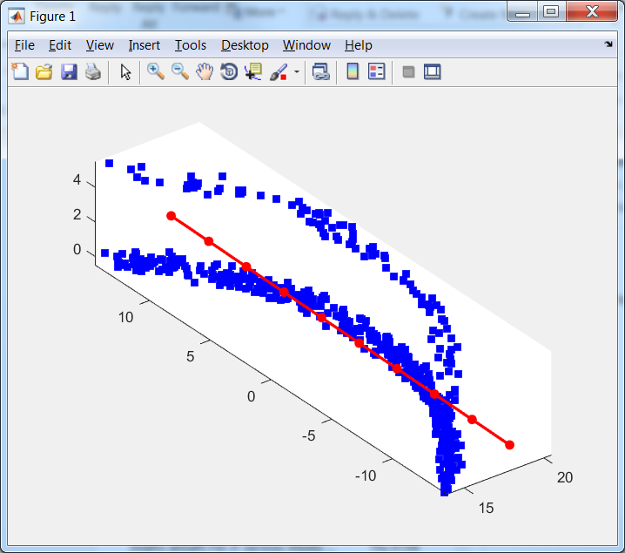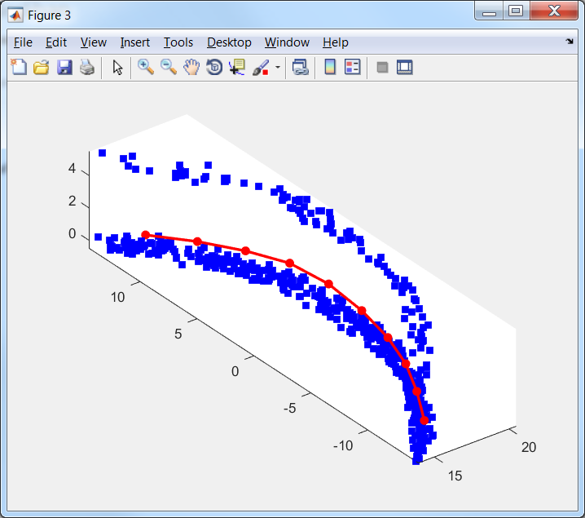

Figure 15. EM(map, data, 'stretch', 0.01, 'bend', 0.1 );

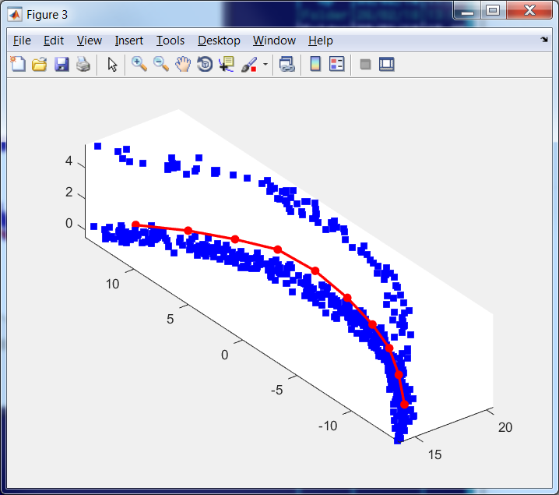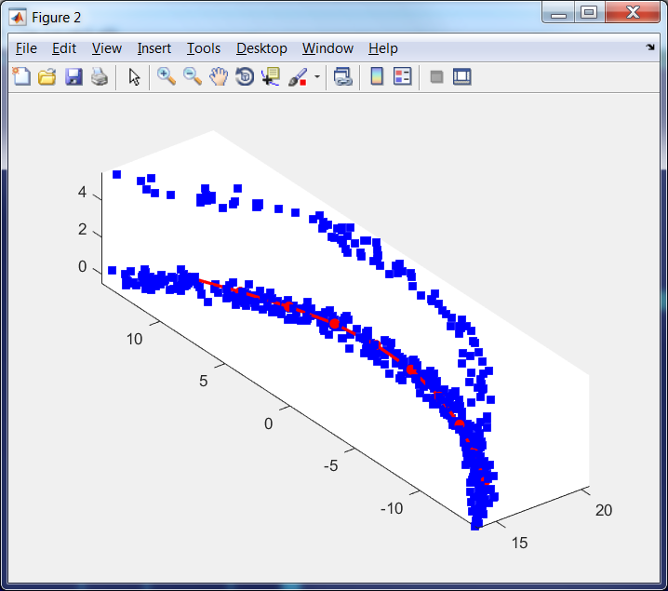

Figure 16. EM(map, data, 'stretch', 0.01, 'bend', 0.1, 'potential', @L2, 'Number_of_intervals', 2); left

EM(map, data, 'stretch', 0.01, 'bend', 0.1, 'potential', @L1, 'Number_of_intervals', 5); right

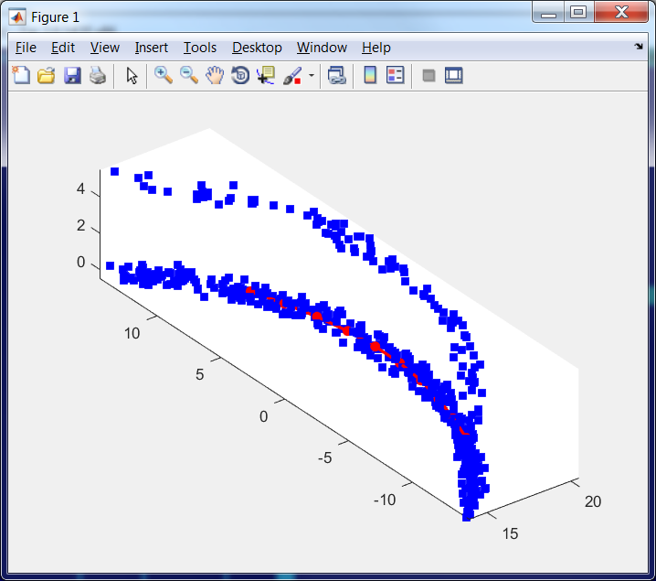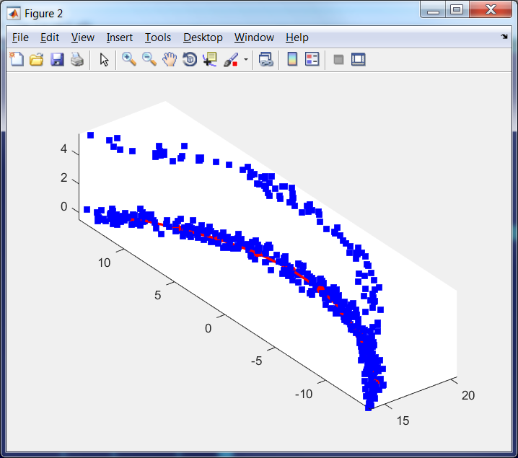

Figure 17. EM(map, data, 'stretch', 0.01, 'bend', 0.1, 'potential', @LLog, 'Number_of_intervals', 5); left

EM(map, data, 'stretch', 0.01, 'bend', 0.1, 'potential', @L2, 'Number_of_intervals', 2, 'intshrinkage', 0.7); right

We can see that LLog or L1 norm have approximately the same robustness property as L2 with trimming.

## Two arcs with x and y shift

Data set contains two arcs with shift 5 in $x$ direction. The shifted arc contains 100 points and the bottom arc contains 400 points.

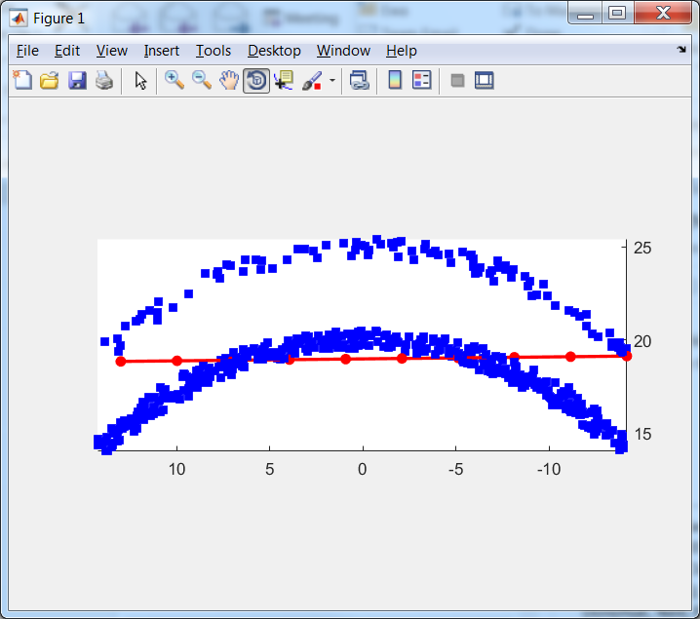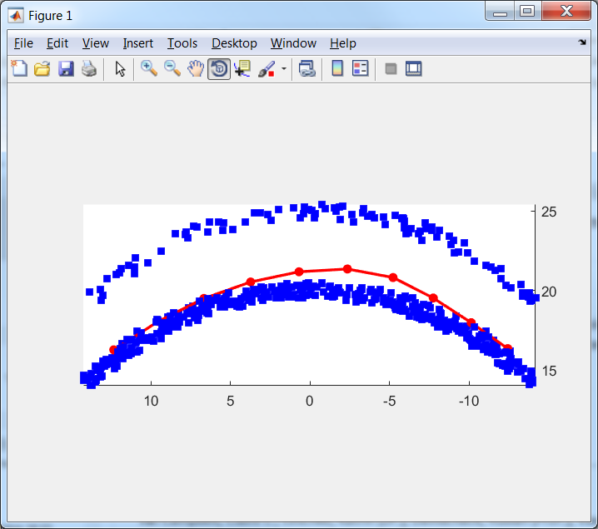

Figure 18. EM(map, data, 'stretch', 0.01, 'bend', 0.1 );

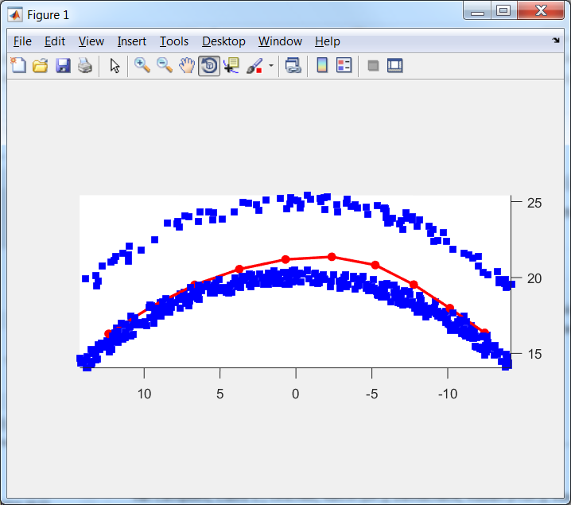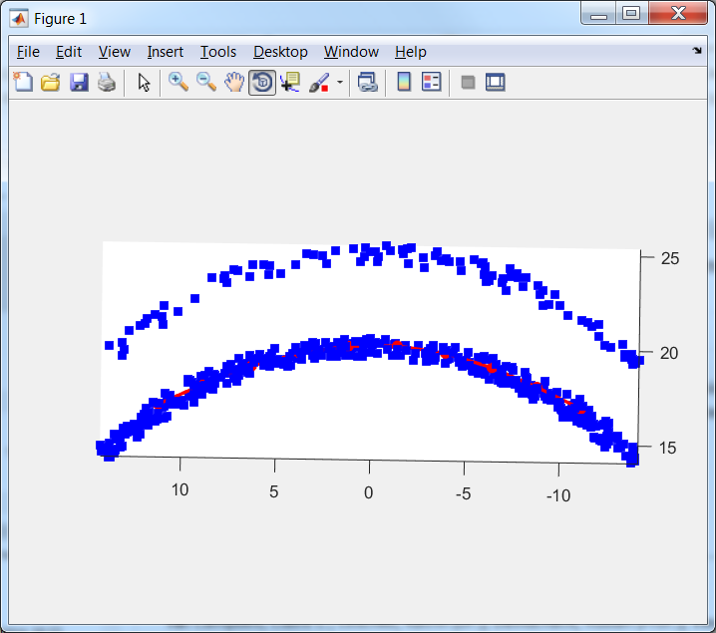

Figure 19. EM(map, data, 'stretch', 0.01, 'bend', 0.1, 'potential', @L2, 'Number_of_intervals', 2); left

EM(map, data, 'stretch', 0.01, 'bend', 0.1, 'potential', @L1, 'Number_of_intervals', 5); right

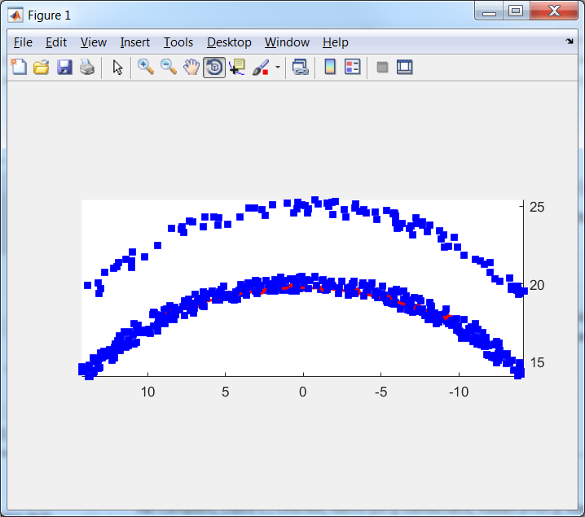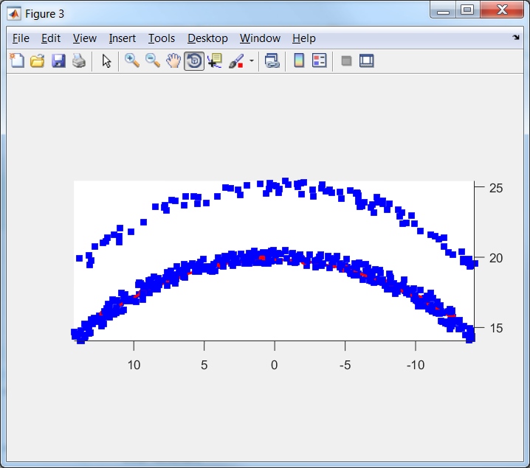

Figure 20. EM(map, data, 'stretch', 0.01, 'bend', 0.1, 'potential', @LLog, 'Number_of_intervals', 5); left

EM(map, data, 'stretch', 0.01, 'bend', 0.1, 'potential', @L2, 'Number_of_intervals', 2, 'intshrinkage', 0.5);

We can see that LLog or L1 norm have approximately the same robustness property as L2 with trimming. We can also estimate uniformity of nodes loading.

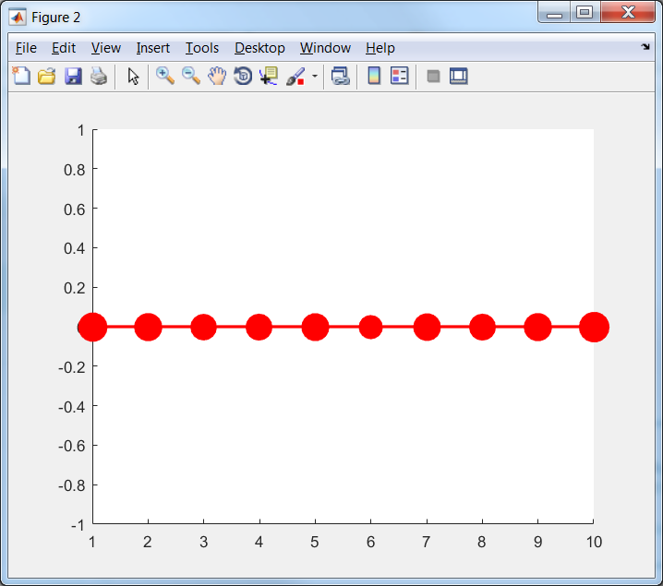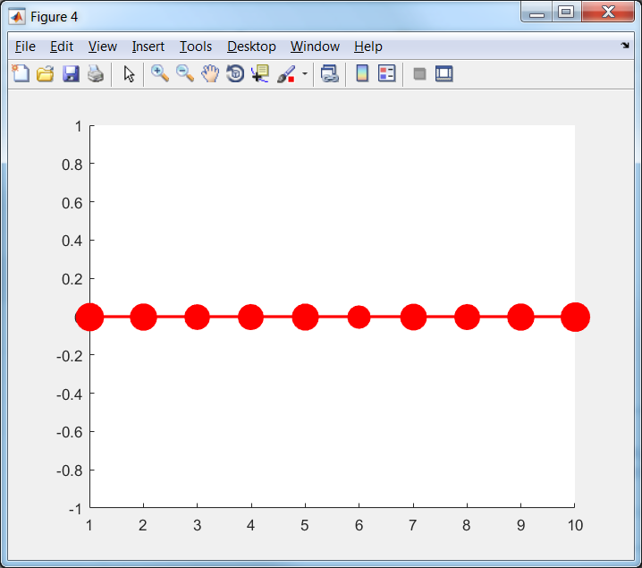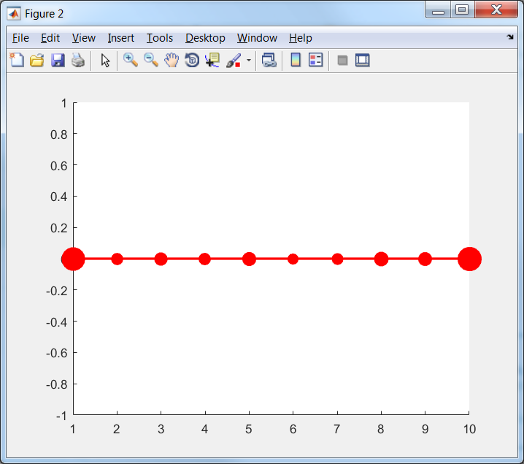

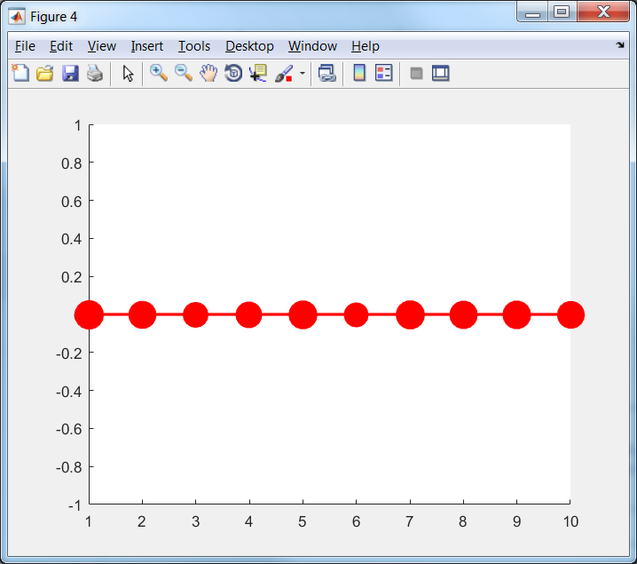

Figure 21. Left to right< top – down:

EM(map, data, 'stretch', 0.01, 'bend', 0.1 );

EM(map, data, 'stretch', 0.01, 'bend', 0.1, 'potential', @L2, 'Number_of_intervals', 2);

EM(map, data, 'stretch', 0.01, 'bend', 0.1, 'potential', @L1, 'Number_of_intervals', 5);

EM(map, data, 'stretch', 0.01, 'bend', 0.1, 'potential', @LLog, 'Number_of_intervals', 5);

EM(map, data, 'stretch', 0.01, 'bend', 0.1, 'potential', @L2, 'Number_of_intervals', 2, 'intshrinkage', 0.5);

We can see that all $L_{2}$ based graphs have approximately uniform distribution of number of points per node (approximately the same size of all nodes). $L_{1}$ and $L_{log}$ based maps are considerably less uniform. This effect can be compensated by decreasing of stretch modulo (see Figure 22).

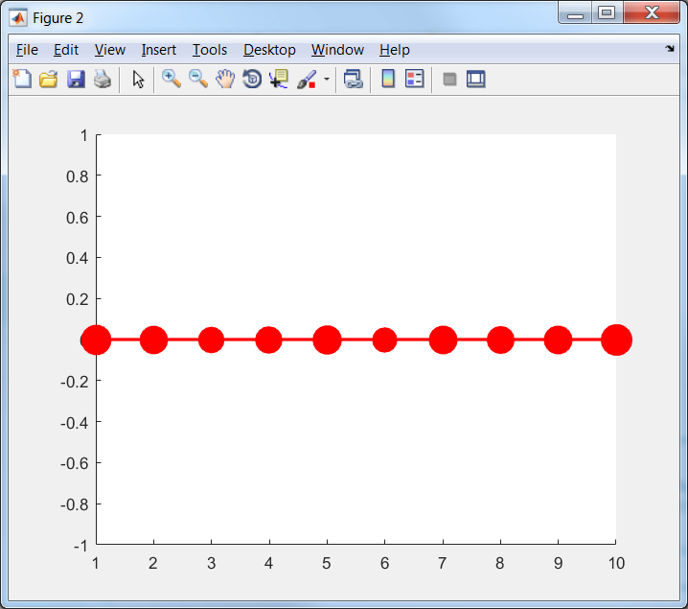

Figure 22. EM(map, data, 'stretch', 0.01, 'bend', 0.1, 'potential', @L1, 'Number_of_intervals', 5); left

EM(map, data, 'stretch', 0.001, 'bend', 0.1, 'potential', @L1, 'Number_of_intervals', 5); right

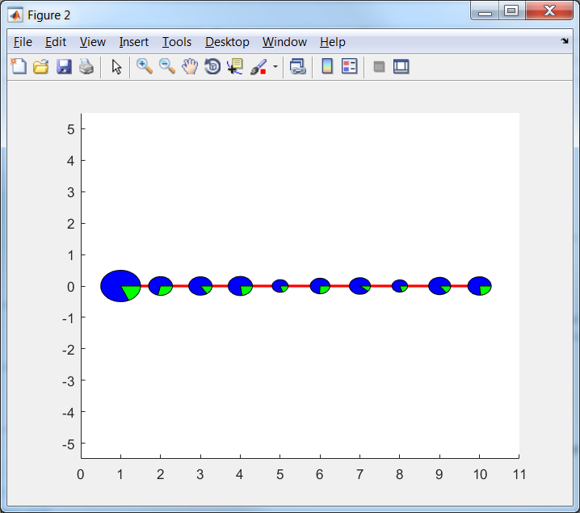

Figure 23. EM(map, data, 'stretch', 0.001, 'bend', 0.1, 'potential', @L1, 'Number_of_intervals', 5);

## Fragment of sphere

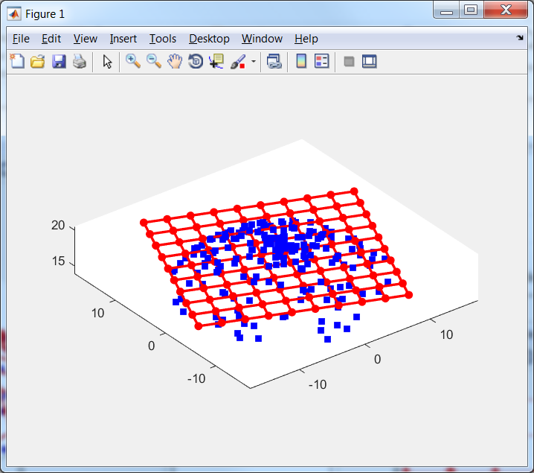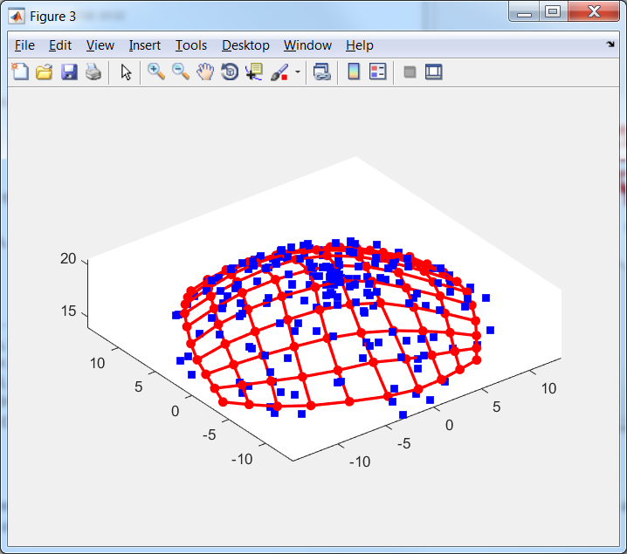

Figure 24. EM(map, data, 'stretch', 0.001, 'bend', 0.01);

## Two fragments of sphere

Data set contains two fragments of sphere with shift 5 in $z$ direction. The shifted sphere contains 100 points (green) and the bottom fragment of sphere contains 400 points.

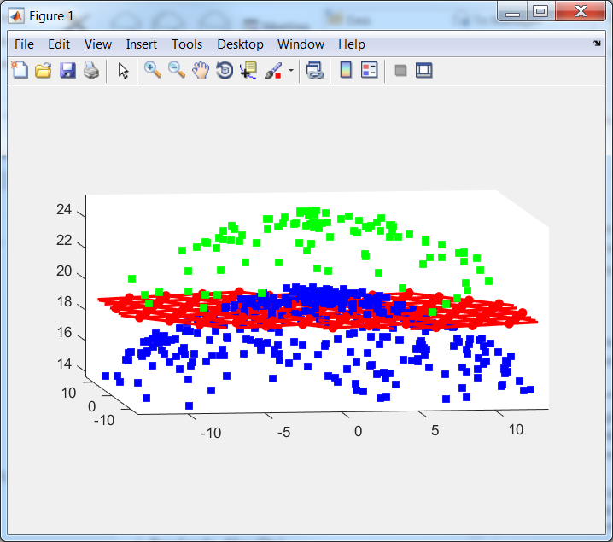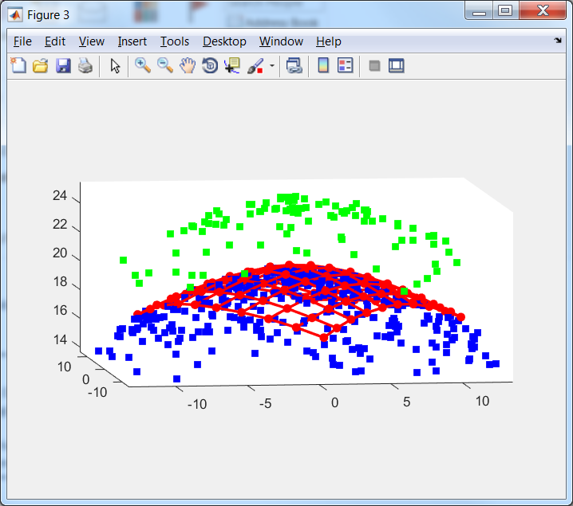

Figure 25. EM(map, data, 'stretch', 0.01, 'bend', 0.1);

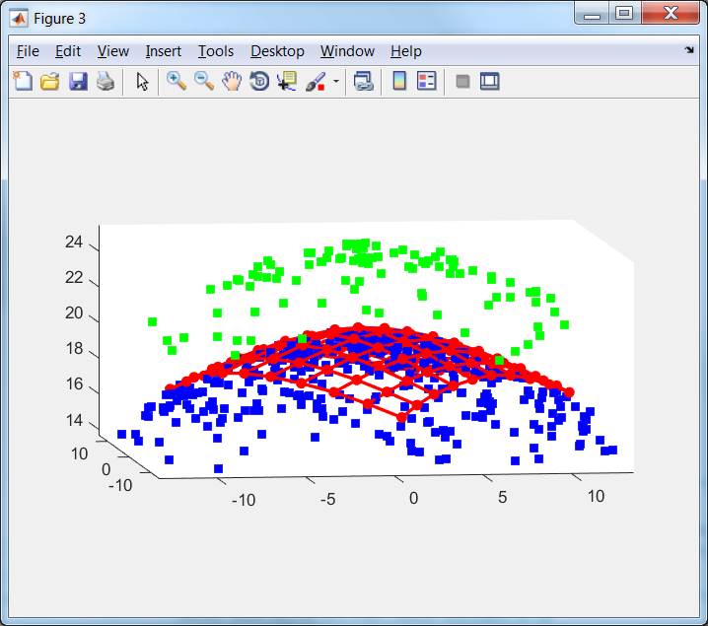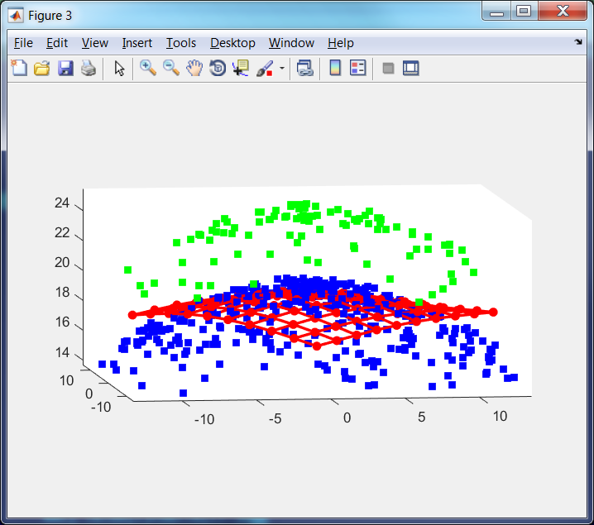

Figure 26. EM(map, data, 'stretch', 0.01, 'bend', 0.1, 'potential', @L2, 'Number_of_intervals', 2); left

EM(map, data, 'stretch', 0.001, 'bend', 0.1, 'potential', @L1, 'Number_of_intervals', 5); right

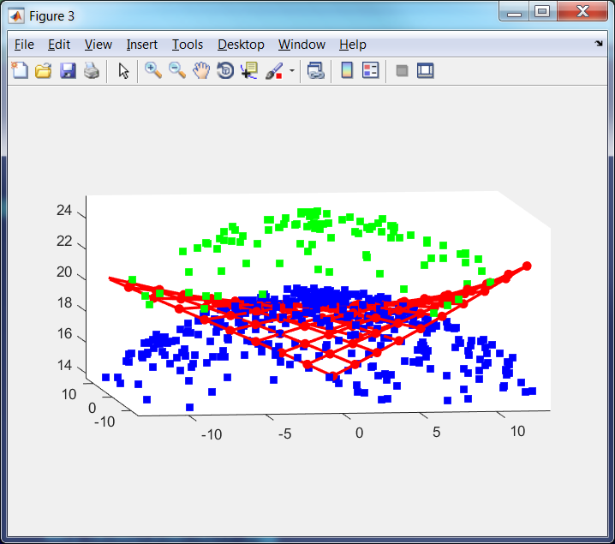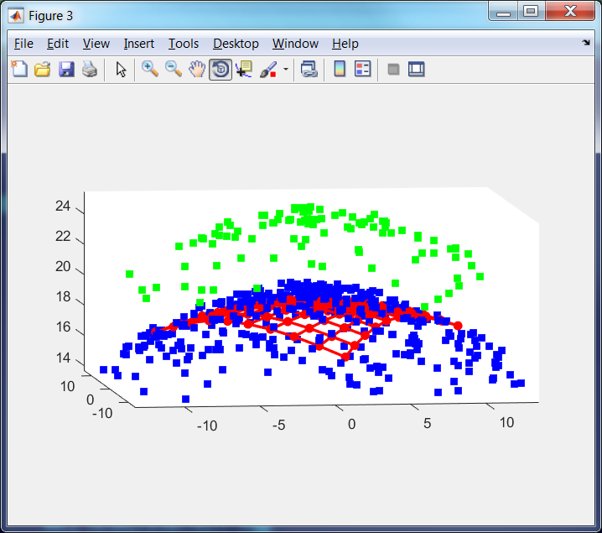

Figure 27. EM(map, data, 'stretch', 0.0001, 'bend', 0.1, 'potential', @LLog, 'Number_of_intervals', 5);left

EM(map, data, 'stretch', 0.01, 'bend', 0.1, 'potential', @L2, 'Number_of_intervals', 2, 'intshrinkage', 0.5);

We can see that for this data robustness of $L_{1}$ and $L_{log}$ based maps are considerably worse. Moreover to avoid of almost collapse of maps we decrease stretch modulo 10 times for $L_{1}$ based map and 100 times for $L_{log}$ based map. Both $L_{1}$ and $L_{log}$ based maps are far from desirable shape. This mean that for such data the $L_{2}$ based map with trimming is preferable.

# Appendix A. Formulas derivation

For formula (12):

$$dist^{2}\left(d,d^{'}\right)=\sum_{i=1}^{n}{{\left(d_{i}-a_{0}^{n}y_{0i}-a_{1}^{n}y_{1i}-\left(1-a_{0}^{n}-a_{1}^{n}\right)y_{2i}\right)}^{2}}=\left(d-y_{2}+a_{0}^{n}y_{20}+a_{1}^{n}y_{21},d-y_{2}+a_{0}^{n}y_{20}+a_{1}^{n}y_{21}\right)=\left(d,d\right)-2\left(d,y_{2}\right)+\left(y_{2},y_{2}\right)+2a_{0}^{n}\left(d-y_{2},y_{20}\right)+2a_{1}^{n}\left(d-y_{2},y_{21}\right)+2a_{0}^{n}a_{1}^{n}\left(y_{20},y_{21}\right)+{a_{0}^{n}}^{2}\left(y_{20},y_{20}\right)+{a_{1}^{n}}^{2}\left(y_{21},y_{21}\right)=\left(d,d\right)-2\left(d,y_{2}\right)+\left(y_{2},y_{2}\right)-2a_{0}^{n}a_{20}\left(y_{20},y_{20}\right)-2a_{1}^{n}a_{21}\left(y_{21},y_{21}\right)+2a_{0}^{n}a_{1}^{n}\left(y_{20},y_{21}\right)+{a_{0}^{n}}^{2}\left(y_{20},y_{20}\right)+{a_{1}^{n}}^{2}\left(y_{21},y_{21}\right)=\left(d,d\right)-2\left(d,y_{2}\right)+\left(y_{2},y_{2}\right)+a_{0}^{n}\left(y_{20},y_{20}\right)\left(a_{0}^{n}-2a_{20}\right)+a_{1}^{n}\left(y_{21},y_{21}\right)\left(a_{1}^{n}-2a_{21}\right)+2a_{0}^{n}a_{1}^{n}\left(y_{20},y_{21}\right).$$

Formula (22):

$$\frac{∂U_{d}}{∂n_{ij}}=\frac{∂}{∂n_{ij}}\frac{1}{N}\sum_{k=1}^{N}{{\left\|d_{k}-n\left(d_{k}\right)\right\|}^{2}}=\frac{1}{N}\frac{∂}{∂n_{ij}}\sum_{\begin{aligned}k=1 \\ n\left(d_{k}\right)=n_{i}\end{aligned}}^{N}{{\left\|d_{k}-n_{i}\right\|}^{2}}+\frac{1}{N}\frac{∂}{∂n_{ij}}\sum_{\begin{aligned}k=1 \\ n\left(d_{k}\right)≠n_{i}\end{aligned}}^{N}{{\left\|d_{k}-n\left(d_{k}\right)\right\|}^{2}}=\frac{1}{N}\sum_{\begin{aligned}k=1 \\ n\left(d_{k}\right)=n_{i}\end{aligned}}^{N}{\frac{∂}{∂n_{ij}}{\left\|d_{k}-n_{i}\right\|}^{2}}=\frac{1}{N}\sum_{\begin{aligned}k=1 \\ n\left(d_{k}\right)=n_{i}\end{aligned}}^{N}{\frac{∂}{∂n_{ij}}\sum_{l=1}^{D}{{\left(d_{kl}-n_{il}\right)}^{2}}}=\frac{1}{N}\sum_{\begin{aligned}k=1 \\ n\left(d_{k}\right)=n_{i}\end{aligned}}^{N}{\frac{∂}{∂n_{ij}}{\left(d_{kj}-n_{ij}\right)}^{2}}=\frac{2}{N}\sum_{\begin{aligned}k=1 \\ n\left(d_{k}\right)=n_{i}\end{aligned}}^{N}{\left(n_{ij}-d_{kj}\right)}.$$

For formula (23):

$$\frac{∂U_{e}}{∂n_{ij}}=\frac{∂}{∂n_{ij}}λ\sum_{k=1}^{E}{{\left\|n_{e_{k0}}-n_{e_{k1}}\right\|}^{2}}=λ\frac{∂}{∂n_{ij}}\sum_{\begin{aligned}k=1 \\ e_{k0}=i\end{aligned}}^{E}{{\left\|n_{i}-n_{e_{k1}}\right\|}^{2}}+λ\frac{∂}{∂n_{ij}}\sum_{\begin{aligned}k=1 \\ e_{ki}=i\end{aligned}}^{E}{{\left\|n_{e_{k0}}-n_{i}\right\|}^{2}}+λ\frac{∂}{∂n_{ij}}\sum_{\begin{aligned}k=1 \\ e_{k0}≠i≠e_{k1}\end{aligned}}^{E}{{\left\|n_{e_{k0}}-n_{e_{k1}}\right\|}^{2}}=λ\sum_{\begin{aligned}k=1 \\ e_{k0}=i\end{aligned}}^{E}{\frac{∂}{∂n_{ij}}\sum_{l=1}^{D}{{\left(n_{il}-n_{e_{k1}l}\right)}^{2}}}+λ\sum_{\begin{aligned}k=1 \\ e_{ki}=i\end{aligned}}^{E}{\frac{∂}{∂n_{ij}}\sum_{l=1}^{D}{{\left(n_{e_{k0}l}-n_{il}\right)}^{2}}}=2λ\sum_{\begin{aligned}k=1 \\ e_{k0}=n_{i}\end{aligned}}^{E}{\left(n_{ij}-n_{e_{k1}j}\right)}+2λ\sum_{\begin{aligned}k=1 \\ e_{k0}=n_{i}\end{aligned}}^{E}{\left(n_{ij}-n_{e_{k0}j}\right)}$$

For formula (24):

$$\frac{∂U_{r}}{∂n_{ij}}=μ\frac{∂}{∂n_{ij}}\sum_{k=1}^{R}{{\left\|n_{r_{k0}}-2n_{r_{k1}}+n_{r_{k2}}\right\|}^{2}}=μ\frac{∂}{∂n_{ij}}\sum_{\begin{aligned}k=1 \\ r_{k0}=i\end{aligned}}^{R}{{\left\|n_{i}-2n_{r_{k1}}+n_{r_{k2}}\right\|}^{2}}+μ\frac{∂}{∂n_{ij}}\sum_{\begin{aligned}k=1 \\ r_{k1}=i\end{aligned}}^{R}{{\left\|n_{r_{k0}}-2n_{i}+n_{r_{k2}}\right\|}^{2}}+μ\frac{∂}{∂n_{ij}}\sum_{\begin{aligned}k=1 \\ r_{k2}=i\end{aligned}}^{R}{{\left\|n_{r_{k0}}-2n_{r_{k1}}+n_{i}\right\|}^{2}}+μ\frac{∂}{∂n_{ij}}\sum_{\begin{aligned}k=1 \\ r_{kl}≠i\end{aligned}}^{R}{{\left\|n_{r_{k0}}-2n_{r_{k1}}+n_{r_{k2}}\right\|}^{2}}=μ\frac{∂}{∂n_{ij}}\sum_{\begin{aligned}k=1 \\ r_{k0}=i\end{aligned}}^{R}{\sum_{l=1}^{D}{{\left(n_{il}-2n_{r_{k1}l}+n_{r_{k2}l}\right)}^{2}}}+μ\frac{∂}{∂n_{ij}}\sum_{\begin{aligned}k=1 \\ r_{k1}=i\end{aligned}}^{R}{\sum_{l=1}^{D}{{\left(n_{r_{k0}l}-2n_{il}+n_{r_{k2}l}\right)}^{2}}}+μ\frac{∂}{∂n_{ij}}\sum_{\begin{aligned}k=1 \\ r_{k2}=i\end{aligned}}^{R}{\sum_{l=1}^{D}{{\left(n_{r_{k0}l}-2n_{r_{k1}l}+n_{il}\right)}^{2}}}=2μ\sum_{\begin{aligned}k=1 \\ r_{k0}=i\end{aligned}}^{R}{\left(n_{ij}-2n_{r_{k1}j}+n_{r_{k2}j}\right)}-4μ\sum_{\begin{aligned}k=1 \\ r_{k1}=i\end{aligned}}^{R}{\left(n_{r_{k0}j}-2n_{ij}+n_{r_{k2}j}\right)}+2μ\sum_{\begin{aligned}k=1 \\ r_{k2}=i\end{aligned}}^{R}{\left(n_{r_{k0}j}-2n_{r_{k1}j}+n_{ij}\right)}$$

# Appendix B. Examples of map descriptions

This appendix contains examples of complete descriptions of small maps as example for simple understanding.

## OneDMap

Let us consider OneDMap with four nodes.

2

3

2

1

4

3

2

1

1

Figure 28. Example of the one dimensional map with four nodes: nodes’ numbers are located above the node, edges’ numbers are located below edge, ribs are depicted by red lines and its numbers are located below rib.

Map creation:

oneMap = OneDMap(4);

Initialization:

init(oneMap, data, 'pci');

or

oneMap.init(data, 'pci');

where data is matrix of data points.

Figure of map in the internal coordinates is presented in Figure 28.

Internal coordinates of nodes are presented in Table 4

Table 4. Internal coordinates of oneMap

|  |  |  |  |  |
| --- | --- | --- | --- | --- |
| Node number | 1 | 2 | 3 | 4 |
| X coordinate | 1 | 2 | 3 | 4 |

List of edges is presented in Table 5. List of ribs is presented in Table 6.

|  |  |  |  |  |  |  |  |  |  |  |  |  |  |  |  |  |  |  |  |  |  |  |  |  |  |
| --- | --- | --- | --- | --- | --- | --- | --- | --- | --- | --- | --- | --- | --- | --- | --- | --- | --- | --- | --- | --- | --- | --- | --- | --- | --- |
| Table 5. List of edges of oneMap   |  |  |  | | --- | --- | --- | | Edge # | Node 1 | Node 2 | | 1 | 1 | 2 | | 2 | 2 | 3 | | 3 | 3 | 4 | | Table 6. List of ribs of oneMap   |  |  |  |  | | --- | --- | --- | --- | | Rib # | Node 1 | Node 2 | Node 3 | | 1 | 1 | 2 | 3 | | 2 | 2 | 3 | 4 | |

Matrices $B$ and $C$ for EM (25) are presented below

$$B=\left(\begin{matrix}1 & -1 & 0 & 0 \\ -1 & 2 & -1 & 0 \\ 0 & -1 & 2 & -1 \\ 0 & 0 & -1 & 1\end{matrix}\right),C=\left(\begin{matrix}1 & -2 & 1 & 0 \\ -2 & 5 & -4 & 1 \\ 1 & -4 & 5 & -2 \\ 0 & 1 & -2 & 1\end{matrix}\right)$$

## rect2DMap

Let us consider rect2DMap with four nodes in each row and column.

13

14

15

16

9

10

11

12

5

6

7

8

3

2

1

4

3

2

1

Figure 29. Example of the rectangular 2D map: nodes’ numbers are located left above the nodes; edges’ numbers are located below horizontal edge and at right side of vertical edges.

4

5

6

7

8

9

10

11

12

13

14

15

16

17

18

19

20

21

22

23

24

Map creation:

rectMap = rect2DMap (4,4);

Initialization:

init(rectMap, data, 'pci');

or

rectMap.init(data, 'pci');

where data is matrix of data points.

Figure of map in the internal coordinates is presented in Figure 29. Numbers of ribs and faces are not presented in Figure 29. Dotted lines depict the faces borders.

Internal coordinates of nodes are presented in Table 7. Lists of edges, ribs and faces are presented in Table 8, Table 9 and Table 10.

Table 7. Internal coordinates of rectMap

|  |  |  |  |  |  |  |  |  |  |  |  |  |  |  |  |  |
| --- | --- | --- | --- | --- | --- | --- | --- | --- | --- | --- | --- | --- | --- | --- | --- | --- |
| Node number | 1 | 2 | 3 | 4 | 5 | 6 | 7 | 8 | 9 | 10 | 11 | 12 | 13 | 14 | 15 | 16 |
| X coordinate | 1 | 1 | 1 | 1 | 2 | 2 | 2 | 2 | 3 | 3 | 3 | 3 | 4 | 4 | 4 | 4 |
| Y coordinate | 1 | 2 | 3 | 4 | 1 | 2 | 3 | 4 | 1 | 2 | 3 | 4 | 1 | 2 | 3 | 4 |

Table 8. List of edges of rectMap

| Edge # | Node 1 | Node 2 |  | Edge # | Node 1 | Node 2 |  | Edge # | Node 1 | Node 2 |
| --- | --- | --- | --- | --- | --- | --- | --- | --- | --- | --- |
| 1 | 1 | 2 |  | 9 | 11 | 12 |  | 17 | 5 | 9 |
| 2 | 2 | 3 |  | 10 | 13 | 14 |  | 18 | 6 | 10 |
| 3 | 3 | 4 |  | 11 | 14 | 15 |  | 19 | 7 | 11 |
| 4 | 5 | 6 |  | 12 | 15 | 16 |  | 20 | 8 | 12 |
| 5 | 6 | 7 |  | 13 | 1 | 5 |  | 21 | 9 | 13 |
| 6 | 7 | 8 |  | 14 | 2 | 6 |  | 22 | 10 | 14 |
| 7 | 9 | 10 |  | 15 | 3 | 7 |  | 23 | 11 | 15 |
| 8 | 10 | 11 |  | 16 | 4 | 8 |  | 24 | 12 | 16 |

Table 9. List of ribs of rectMap

| Rib # | Node 1 | Node 2 | Node 3 |  | Rib # | Node 1 | Node 2 | Node 3 |  | Rib # | Node 1 | Node 2 | Node 3 |
| --- | --- | --- | --- | --- | --- | --- | --- | --- | --- | --- | --- | --- | --- |
| 1 | 1 | 2 | 3 |  | 7 | 13 | 14 | 15 |  | 12 | 4 | 8 | 12 |
| 2 | 2 | 3 | 4 |  | 8 | 14 | 15 | 16 |  | 13 | 5 | 9 | 13 |
| 3 | 5 | 6 | 7 |  | 9 | 1 | 5 | 9 |  | 14 | 6 | 10 | 14 |
| 4 | 6 | 7 | 8 |  | 10 | 2 | 6 | 10 |  | 15 | 7 | 11 | 15 |
| 5 | 9 | 10 | 11 |  | 11 | 3 | 7 | 11 |  | 16 | 8 | 12 | 16 |
| 6 | 10 | 11 | 12 |  |  |  |  |  |  |  |  |  |  |

Table 10. List of faces of rectMap

| Rib # | Node 1 | Node 2 | Node 3 |  | Rib # | Node 1 | Node 2 | Node 3 |  | Rib # | Node 1 | Node 2 | Node 3 |
| --- | --- | --- | --- | --- | --- | --- | --- | --- | --- | --- | --- | --- | --- |
| 1 | 1 | 2 | 5 |  | 7 | 9 | 10 | 13 |  | 13 | 9 | 6 | 10 |
| 2 | 2 | 3 | 6 |  | 8 | 10 | 11 | 14 |  | 14 | 10 | 7 | 11 |
| 3 | 3 | 4 | 7 |  | 9 | 11 | 12 | 15 |  | 15 | 11 | 8 | 12 |
| 4 | 5 | 6 | 9 |  | 10 | 5 | 2 | 6 |  | 16 | 13 | 10 | 14 |
| 5 | 6 | 7 | 10 |  | 11 | 6 | 3 | 7 |  | 17 | 14 | 11 | 15 |
| 6 | 7 | 8 | 11 |  | 12 | 7 | 4 | 8 |  | 18 | 15 | 12 | 16 |

Matrices $B$ and $C$ for EM (25) are presented below

$$B=\left(\begin{matrix}2 & -1 & 0 & 0 & -1 & 0 & 0 & 0 & 0 & 0 & 0 & 0 & 0 & 0 & 0 & 0 \\ -1 & 3 & -1 & 0 & 0 & -1 & 0 & 0 & 0 & 0 & 0 & 0 & 0 & 0 & 0 & 0 \\ 0 & -1 & 3 & -1 & 0 & 0 & -1 & 0 & 0 & 0 & 0 & 0 & 0 & 0 & 0 & 0 \\ 0 & 0 & -1 & 2 & 0 & 0 & 0 & -1 & 0 & 0 & 0 & 0 & 0 & 0 & 0 & 0 \\ -1 & 0 & 0 & 0 & 3 & -1 & 0 & 0 & -1 & 0 & 0 & 0 & 0 & 0 & 0 & 0 \\ 0 & -1 & 0 & 0 & -1 & 4 & -1 & 0 & 0 & -1 & 0 & 0 & 0 & 0 & 0 & 0 \\ 0 & 0 & -1 & 0 & 0 & -1 & 4 & -1 & 0 & 0 & -1 & 0 & 0 & 0 & 0 & 0 \\ 0 & 0 & 0 & -1 & 0 & 0 & -1 & 3 & 0 & 0 & 0 & -1 & 0 & 0 & 0 & 0 \\ 0 & 0 & 0 & 0 & -1 & 0 & 0 & 0 & 3 & -1 & 0 & 0 & -1 & 0 & 0 & 0 \\ 0 & 0 & 0 & 0 & 0 & -1 & 0 & 0 & -1 & 4 & -1 & 0 & 0 & -1 & 0 & 0 \\ 0 & 0 & 0 & 0 & 0 & 0 & -1 & 0 & 0 & -1 & 4 & -1 & 0 & 0 & -1 & 0 \\ 0 & 0 & 0 & 0 & 0 & 0 & 0 & -1 & 0 & 0 & -1 & 3 & 0 & 0 & 0 & -1 \\ 0 & 0 & 0 & 0 & 0 & 0 & 0 & 0 & -1 & 0 & 0 & 0 & 2 & -1 & 0 & 0 \\ 0 & 0 & 0 & 0 & 0 & 0 & 0 & 0 & 0 & -1 & 0 & 0 & -1 & 3 & -1 & 0 \\ 0 & 0 & 0 & 0 & 0 & 0 & 0 & 0 & 0 & 0 & -1 & 0 & 0 & -1 & 3 & -1 \\ 0 & 0 & 0 & 0 & 0 & 0 & 0 & 0 & 0 & 0 & 0 & -1 & 0 & 0 & -1 & 2\end{matrix}\right),$$

$$C=\left(\begin{matrix}2 & -2 & 1 & 0 & -2 & 0 & 0 & 0 & 1 & 0 & 0 & 0 & 0 & 0 & 0 & 0 \\ -2 & 6 & -4 & 1 & 0 & -2 & 0 & 0 & 0 & 1 & 0 & 0 & 0 & 0 & 0 & 0 \\ 1 & -4 & 6 & -2 & 0 & 0 & -2 & 0 & 0 & 0 & 1 & 0 & 0 & 0 & 0 & 0 \\ 0 & 1 & -2 & 2 & 0 & 0 & 0 & -2 & 0 & 0 & 0 & 1 & 0 & 0 & 0 & 0 \\ -2 & 0 & 0 & 0 & 6 & -2 & 1 & 0 & -4 & 0 & 0 & 0 & 1 & 0 & 0 & 0 \\ 0 & -2 & 0 & 0 & -2 & 10 & -4 & 1 & 0 & -4 & 0 & 0 & 0 & 1 & 0 & 0 \\ 0 & 0 & -2 & 0 & 1 & -4 & 10 & -2 & 0 & 0 & -4 & 0 & 0 & 0 & 1 & 0 \\ 0 & 0 & 0 & -2 & 0 & 1 & -2 & 6 & 0 & 0 & 0 & -4 & 0 & 0 & 0 & 1 \\ 1 & 0 & 0 & 0 & -4 & 0 & 0 & 0 & 6 & -2 & 1 & 0 & -2 & 0 & 0 & 0 \\ 0 & 1 & 0 & 0 & 0 & -4 & 0 & 0 & -2 & 10 & -4 & 1 & 0 & -2 & 0 & 0 \\ 0 & 0 & 1 & 0 & 0 & 0 & -4 & 0 & 1 & -4 & 10 & -2 & 0 & 0 & -2 & 0 \\ 0 & 0 & 0 & 1 & 0 & 0 & 0 & -4 & 0 & 1 & -2 & 6 & 0 & 0 & 0 & -2 \\ 0 & 0 & 0 & 0 & 1 & 0 & 0 & 0 & -2 & 0 & 0 & 0 & 2 & -2 & 1 & 0 \\ 0 & 0 & 0 & 0 & 0 & 1 & 0 & 0 & 0 & -2 & 0 & 0 & -2 & 6 & -4 & 1 \\ 0 & 0 & 0 & 0 & 0 & 0 & 1 & 0 & 0 & 0 & -2 & 0 & 1 & -4 & 6 & -2 \\ 0 & 0 & 0 & 0 & 0 & 0 & 0 & 1 & 0 & 0 & 0 & -2 & 0 & 1 & -2 & 2\end{matrix}\right)$$

## tri2DMap

Let us consider tri2DMap with four rows four nodes in each odd row and three nodes in each even row.

13

14

9

10

11

12

5

6

7

8

3

2

1

4

3

2

1

Figure 30. Example of the triangular 2D map: nodes’ numbers are located above the nodes; edges’ numbers are located near edges and faces’ numbers are located in the centres of triangles.

4

5

6

7

8

9

10

11

12

13

14

15

16

17

18

19

20

21

22

23

24

10

25

26

27

28

1

3

2

4

5

6

7

8

9

10

11

12

13

14

15

Map creation:

triMap = tri2DMap (4,4);

Initialization:

init(triMap, data, ‘pci’);

or

triMap.init(data, ‘pci’);

where data is matrix of data points.

Figure of map in the internal coordinates is presented in Figure 30. Numbers of ribs are not presented in Figure 30.

Internal coordinates of nodes are presented in Table 11. Lists of edges, ribs and faces are presented in Table 12, Table 13 and Table 14.

Table 11. Internal coordinates of triMap

|  |  |  |  |  |  |  |  |  |  |  |  |  |  |  |
| --- | --- | --- | --- | --- | --- | --- | --- | --- | --- | --- | --- | --- | --- | --- |
| Node number | 1 | 2 | 3 | 4 | 5 | 6 | 7 | 8 | 9 | 10 | 11 | 12 | 13 | 14 |
| X coordinate | 1.00 | 2.00 | 3.00 | 4.00 | 1.50 | 2.50 | 3.50 | 1.00 | 2.00 | 3.00 | 4.00 | 1.50 | 2.50 | 3.50 |
| Y coordinate | 0.00 | 0.00 | 0.00 | 0.00 | 0.87 | 0.87 | 0.87 | 1.73 | 1.73 | 1.73 | 1.73 | 2.60 | 2.60 | 2.60 |

Table 12. List of edges of triMap

| Edge # | Node 1 | Node 2 |  | Edge # | Node 1 | Node 2 |  | Edge # | Node 1 | Node 2 |
| --- | --- | --- | --- | --- | --- | --- | --- | --- | --- | --- |
| 1 | 1 | 2 |  | 11 | 1 | 5 |  | 20 | 2 | 5 |
| 2 | 2 | 3 |  | 12 | 2 | 6 |  | 21 | 3 | 6 |
| 3 | 3 | 4 |  | 13 | 3 | 7 |  | 22 | 4 | 7 |
| 4 | 8 | 9 |  | 14 | 8 | 12 |  | 23 | 9 | 12 |
| 5 | 9 | 10 |  | 15 | 9 | 13 |  | 24 | 10 | 13 |
| 6 | 10 | 11 |  | 16 | 10 | 14 |  | 25 | 11 | 14 |
| 7 | 5 | 6 |  | 17 | 5 | 9 |  | 26 | 5 | 8 |
| 8 | 6 | 7 |  | 18 | 6 | 10 |  | 27 | 6 | 9 |
| 9 | 12 | 13 |  | 19 | 7 | 11 |  | 28 | 7 | 10 |
| 10 | 13 | 14 |  |  |  |  |  |  |  |  |

Table 13. List of ribs of triMap

| Rib # | Node 1 | Node 2 | Node 3 |  | Rib # | Node 1 | Node 2 | Node 3 |  | Rib # | Node 1 | Node 2 | Node 3 |
| --- | --- | --- | --- | --- | --- | --- | --- | --- | --- | --- | --- | --- | --- |
| 1 | 1 | 2 | 3 |  | 7 | 1 | 5 | 9 |  | 12 | 2 | 5 | 8 |
| 2 | 2 | 3 | 4 |  | 8 | 2 | 6 | 10 |  | 13 | 3 | 6 | 9 |
| 3 | 8 | 9 | 10 |  | 9 | 3 | 7 | 11 |  | 14 | 4 | 7 | 10 |
| 4 | 9 | 10 | 11 |  | 10 | 5 | 9 | 13 |  | 15 | 6 | 9 | 12 |
| 5 | 5 | 6 | 7 |  | 11 | 6 | 10 | 14 |  | 16 | 7 | 10 | 13 |
| 6 | 12 | 13 | 14 |  |  |  |  |  |  |  |  |  |  |

Table 14. List of faces of triMap

| Rib # | Node 1 | Node 2 | Node 3 |  | Rib # | Node 1 | Node 2 | Node 3 |  | Rib # | Node 1 | Node 2 | Node 3 |
| --- | --- | --- | --- | --- | --- | --- | --- | --- | --- | --- | --- | --- | --- |
| 1 | 1 | 2 | 5 |  | 6 | 10 | 11 | 14 |  | 11 | 9 | 13 | 12 |
| 2 | 2 | 3 | 6 |  | 7 | 5 | 6 | 9 |  | 12 | 10 | 14 | 13 |
| 3 | 3 | 4 | 7 |  | 8 | 6 | 7 | 10 |  | 13 | 5 | 9 | 8 |
| 4 | 8 | 9 | 12 |  | 9 | 2 | 6 | 5 |  | 14 | 6 | 10 | 9 |
| 5 | 9 | 10 | 13 |  | 10 | 3 | 7 | 6 |  | 15 | 7 | 11 | 10 |

Matrices $B$ and $C$ for EM (25) are presented below

$$B=\left(\begin{matrix}2 & -1 & 0 & 0 & -1 & 0 & 0 & 0 & 0 & 0 & 0 & 0 & 0 & 0 \\ -1 & 4 & -1 & 0 & -1 & -1 & 0 & 0 & 0 & 0 & 0 & 0 & 0 & 0 \\ 0 & -1 & 4 & -1 & 0 & -1 & -1 & 0 & 0 & 0 & 0 & 0 & 0 & 0 \\ 0 & 0 & -1 & 2 & 0 & 0 & -1 & 0 & 0 & 0 & 0 & 0 & 0 & 0 \\ -1 & -1 & 0 & 0 & 5 & -1 & 0 & -1 & -1 & 0 & 0 & 0 & 0 & 0 \\ 0 & -1 & -1 & 0 & -1 & 6 & -1 & 0 & -1 & -1 & 0 & 0 & 0 & 0 \\ 0 & 0 & -1 & -1 & 0 & -1 & 5 & 0 & 0 & -1 & -1 & 0 & 0 & 0 \\ 0 & 0 & 0 & 0 & -1 & 0 & 0 & 3 & -1 & 0 & 0 & -1 & 0 & 0 \\ 0 & 0 & 0 & 0 & -1 & -1 & 0 & -1 & 6 & -1 & 0 & -1 & -1 & 0 \\ 0 & 0 & 0 & 0 & 0 & -1 & -1 & 0 & -1 & 6 & -1 & 0 & -1 & -1 \\ 0 & 0 & 0 & 0 & 0 & 0 & -1 & 0 & 0 & -1 & 3 & 0 & 0 & -1 \\ 0 & 0 & 0 & 0 & 0 & 0 & 0 & -1 & -1 & 0 & 0 & 3 & -1 & 0 \\ 0 & 0 & 0 & 0 & 0 & 0 & 0 & 0 & -1 & -1 & 0 & -1 & 4 & -1 \\ 0 & 0 & 0 & 0 & 0 & 0 & 0 & 0 & 0 & -1 & -1 & 0 & -1 & 3\end{matrix}\right),$$

$$C=\left(\begin{matrix}2 & -2 & 1 & 0 & -2 & 0 & 0 & 0 & 1 & 0 & 0 & 0 & 0 & 0 \\ -2 & 7 & -4 & 1 & -2 & -2 & 0 & 1 & 0 & 1 & 0 & 0 & 0 & 0 \\ 1 & -4 & 7 & -2 & 0 & -2 & -2 & 0 & 1 & 0 & 1 & 0 & 0 & 0 \\ 0 & 1 & -2 & 2 & 0 & 0 & -2 & 0 & 0 & 1 & 0 & 0 & 0 & 0 \\ -2 & -2 & 0 & 0 & 10 & -2 & 1 & -2 & -4 & 0 & 0 & 0 & 1 & 0 \\ 0 & -2 & -2 & 0 & -2 & 14 & -2 & 0 & -4 & -4 & 0 & 1 & 0 & 1 \\ 0 & 0 & -2 & -2 & 1 & -2 & 10 & 0 & 0 & -4 & -2 & 0 & 1 & 0 \\ 0 & 1 & 0 & 0 & -2 & 0 & 0 & 2 & -2 & 1 & 0 & 0 & 0 & 0 \\ 1 & 0 & 1 & 0 & -4 & -4 & 0 & -2 & 15 & -4 & 1 & -2 & -2 & 0 \\ 0 & 1 & 0 & 1 & 0 & -4 & -4 & 1 & -4 & 15 & -2 & 0 & -2 & -2 \\ 0 & 0 & 1 & 0 & 0 & 0 & -2 & 0 & 1 & -2 & 2 & 0 & 0 & 0 \\ 0 & 0 & 0 & 0 & 0 & 1 & 0 & 0 & -2 & 0 & 0 & 2 & -2 & 1 \\ 0 & 0 & 0 & 0 & 1 & 0 & 1 & 0 & -2 & -2 & 0 & -2 & 6 & -2 \\ 0 & 0 & 0 & 0 & 0 & 1 & 0 & 0 & 0 & -2 & 0 & 1 & -2 & 2\end{matrix}\right)$$

# References

1. Akinduko, Ayodeji A., Evgeny M. Mirkes, and Alexander N. Gorban. "SOM: Stochastic initialization versus principal components." *Information Sciences*(2015), <http://dx.doi.org/10.1016/j.ins.2015.10.013>
2. Dobson, Annette J., and Adrian Barnett. *An introduction to generalized linear models*. CRC press, 2008.
3. PCA
4. PCA
5. EM first
6. Gorban, A. and Zinovyev, A.Y., 2001. Visualization of data by method of elastic maps and its applications in genomics, economics and sociology. <http://www.ihes.fr/~/zinovyev/papers/M01-36.pdf>
7. <https://en.wikipedia.org/wiki/Distance#Distances_between_sets_and_between_a_point_and_a_set>
8. <https://en.wikipedia.org/wiki/Metric_space#Distance_between_points_and_sets;_Hausdorff_distance_and_Gromov_metric>
9. Gorban & A Rossiev
10. Brand M. (2002) Incremental Singular Value Decomposition of Uncertain Data with Missing Values. In: Heyden A., Sparr G., Nielsen M., Johansen P. (eds) Computer Vision — ECCV 2002. ECCV 2002. Lecture Notes in Computer Science, vol 2350. Springer, Berlin, Heidelberg
11. Kurucz, M., Benczúr, A.A. and Csalogány, K., 2007, August. Methods for large scale SVD with missing values. In *Proceedings of KDD cup and workshop* (Vol. 12, pp. 31-38).